Full Name | C.I. BHATT
Nick Name | Chandu
Branch | Mechanical
Email | cibhatt1324@gmail.com
Phone | 7587179470
Current Location | BHILAI,INDIA
Educational Qualification | B.E.(HONOURS) MECHANICAL
Professional | Joined Bhilai Steel Plant as Graduate Engineer in 1977. Worked in various capacities in Engineering Shops (Spare Parts Manufacturing Complex) and Rolling Mills. Superannuated in 2014 as General Manager of Merchant Mill and Wire Rod Mill.  Member of following Professional Bodies:  1. Institution of Engineers,  2. Indian Institute of Welding,  3. Indian Institute of Plant Engineers
Family | Settled in Bhilai. Post retirement, I am associated with Social Service Group -SEVA Foundation, Bhilai. Wife – Ranjana is housewife. Son-Abhinay is with NMDC, India. Daughter-in-law- Jigna is Ph.D.. Daughter-Abhilasha is with FICO in San-Diego (California).Son-in-law -Kshitij is with Encore in San-Diego (California). Granddaughters and Grandson are school-going students.  We are all blessed by mother Rama Ben Bhatt.
Memory from College Days | बातों को तेरी हम भुला ना सके,  होके जुदा हम ना जुदा हो सके।  दिल में है ज़िंदा हर घड़ी तू कहीं,  होके जुदा हम ना जुदा हो सके।।

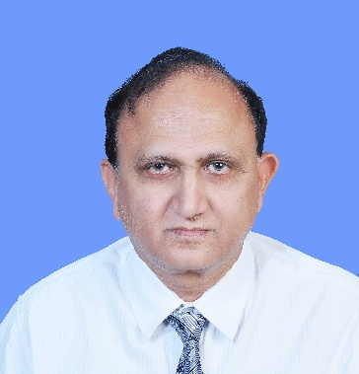  C.I. Bhatt: Now | 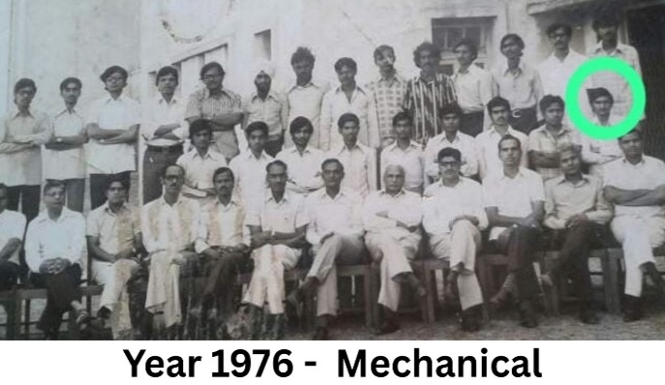  Year 1976- Final Year Mechanical Students with Principal Sir & Professors of Mechanical Branch
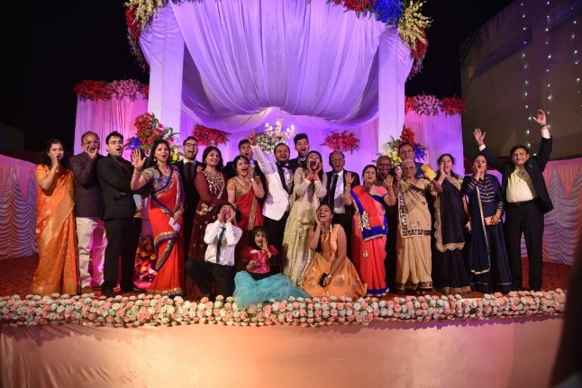  Nephew's Marriage Function  Family Photo | 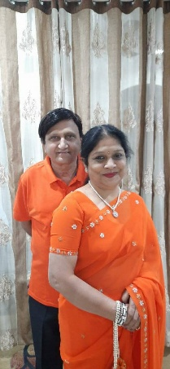  With Spouse

Full Name | Rajeev Jha
Nick Name | --
Branch | Electrical Engineering
Email | rajeevj345@gmail.com
Phone | 7587166528
Current Location | My permanent Location is Bhilai, now in USA
Educational Qualification | B.E. Electrical Engineering
Professional | I joined SAIL , Bhilai as Graduate Engineer in SMS2.I was in training at Lipisk Steel Plant ,Russia for 9 months, till April 1980.I worked in Electrical Testing Commissioning group for 2 years for Plate Mill. Then I was involved in Testing Commissioning of Tundish bay, Argon Rinsing, Casting Cranes. Later I joined Project Planning & Engg Deptt. Where I was involved in Electrical Depts., Utility Depts. Instrumentation Dept. project planning and monitoring execution schedule. Oxygen Plant,MSDS-5 etc. I retired as G.M.
Family | I have two daughters and son. They have done M.S. from USA. They are settled in US. My best half is a housewife.
Memory from College Days | General memories, nothing specific.

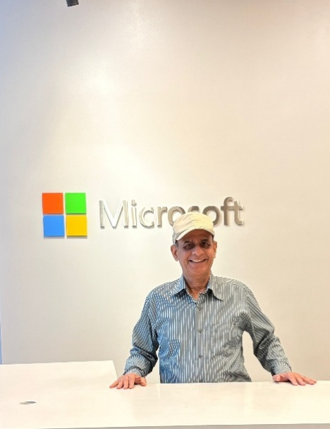  Rajiv Jha: Now | 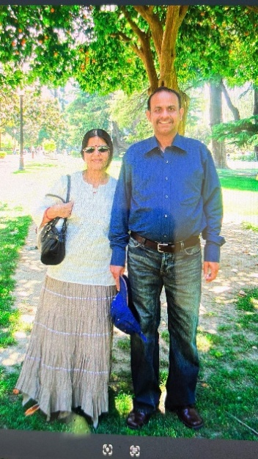  With Spouse

Full Name | Ramesh Kumar Suri
Nick Name | --
Branch | Mining
Email | ramesh.surisail@gmail.com
Phone | 7804982511
Current Location | Bilaspur cg
Educational Qualification | BE (Min) , Diploma in Marketing from IGNOU
Professional | Joined BCCL (CIL)in Nov1977 Dhanbad, resigned in March 1983, again joined CCSO ,a unit of SAIL in Dhanbad. Superannuated on 31 Jan 2013. Settled in Bilaspur along with my parents and family of my son.
Family | Married on 8th March 1980 in Dhanbad. Having one son and one daughter. Daughter married in Feb 2006 at Durg with Sunny Mehra who runs a fabrication Factory. They have two sons. Elder son completed 12th from DPS Bhilai and 2nd son in 8th class DPS Bhilai. My son got married in 2010 and having one daughter and one son who are studying in DAV School Bilaspur in 10th and 8th class respectively.
Memory from College Days | I spent a quiet lonely time during my college days. I was getting only Rs 100 in a month. During college days I remembered only Sunil Agarwal and Budhaditya Mukherjee. Even my service life I remembered to both on many After 2013 I was deeply impressed with Uday, Ramesh Punjabi and Zaki.

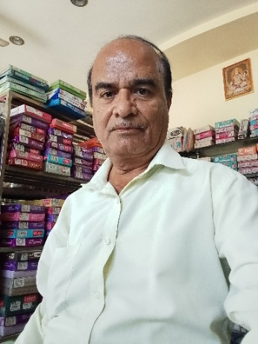  Ramesh Kumar Suri: Now | 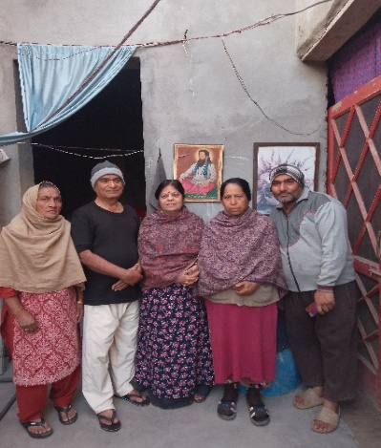  With my wife and family of my cousin’s brother at Gurdaspur
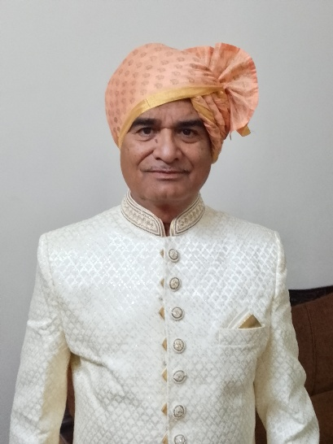  After retirement in a marriage in 2025 at Ludhiana | 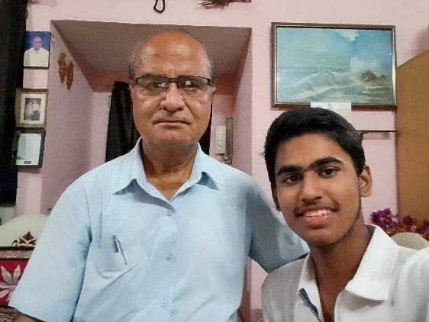  In my garment shop which is operated by my son

Full Name | Harkishor Koshaley
Nick Name | HK
Branch | Mechanical engineering
Email | hk.koshaley@gmail.com
Phone | 9324036573
Current Location | Mumbai, India
Educational Qualification | Graduated in mechanical engineering in 1976 from GEC/NIT, Raipur, and trained at the Indian School of Business, Hyderabad, on the global energy business, business planning, and project management.
Professional | Joined ONGC in 1977 and served 37 years in onshore and offshore maintenance operations, engineering operations, and a three-year stint at GNPOC, Sudan. Superannuated in July 2014 as Executive Director – Head Offshore Maintenance, Western Offshore Assets, ONGC, Mumbai.  Possesses extensive experience in Operations & Maintenance planning and management of petroleum drilling rigs, oil and gas pipelines, tankages, offshore process complexes, workshop refurbishment, and project engineering.  Achievements:  • Received the Chairman’s Manager of the Year Award in 2001 for turning around maintenance performance at the SH Offshore process complex.  • Successfully upgraded maintenance and procurement processes in ONGC’s Western Offshore Assets.  • As Head of Engineering Services, Assam Asset, led major brownfield projects, including the Assam Renewal Project involving replacement of 500 km of pipelines and revamps of Oil and Gas facilities- CTFs, GGSs, WTPs, and Power plants.  • Post-retirement, he mentors students and professionals in self-management and personal effectiveness. A lifelong learner, he explores literature on business, management, astrology, and spirituality, distilling insights into practical writings that bridge professional success with inner growth and holistic well-being.  • Author of The Wisdom of Life and Work (e-book on Kindle) and the fiction book Awakening the Inner Lantern (e-book and paperback on Kindle). Its Hindi paperback edition, आंतरिक लालटेन का जागरण, is in publication with Notion Press.
Family | Family Details:  After graduating and joining ONGC, I married Jyoti in 1979. We were blessed with a daughter, Gauri, and two sons, Tushar and Rahul. Gauri earned an MS in Architecture, is married, and is settled in the United States. Tushar graduated in Electrical Engineering from NIT Bhopal, completed an MBA in Finance in the United States, and is married; he and his wife work as senior managers in multinational companies. Rahul graduated in Computer Engineering and worked as a software engineer at Tech Mahindra. In 2023, he passed away after a serious illness.  Jyoti and I have settled in Mumbai. Gauri and Tushar live in the United States.
Memory from College Days | My college days were difficult because of my family’s financial condition. It was hard to meet even the basic expenses of books and living. Still, I remained simple, decent, and friendly with everyone, and my friends were very supportive.  I remember one time in my second year when I appeared for my examinations after going hungry for two days. One of my college friends knew my situation. He took me to his hostel mess, introduced me to the mess manager, and bore my food expenses for the remaining days of the exams.  Those difficult days actually shaped me and helped me lead a successful and contented life.

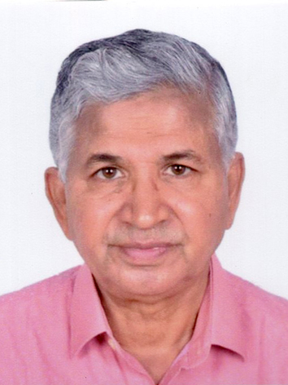  Harkishor Koshaley: Now | 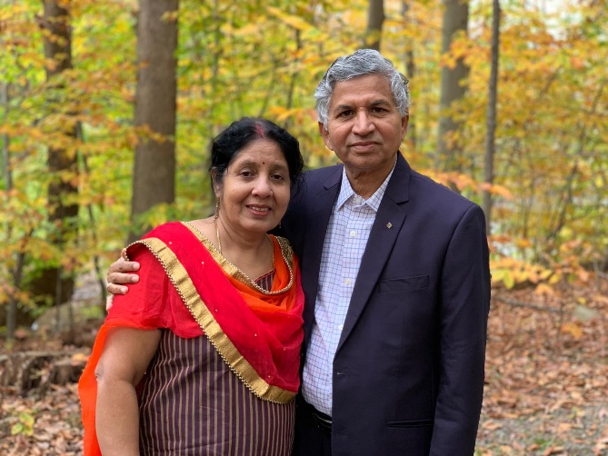  This photo was taken during time spent in USA
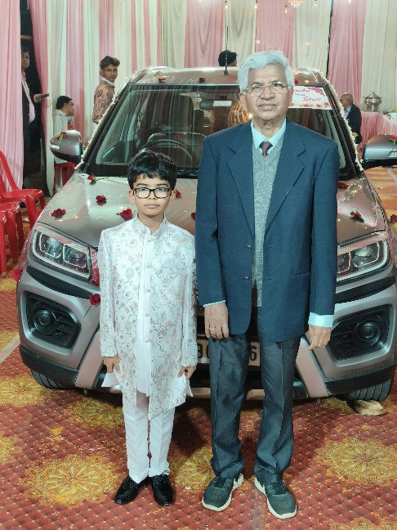
With my Grandson Vihaan in one of the marriage gatherings

Full Name | Ranjana Deshpande Muley
Nick Name | Deshpande
Branch | Electrical
Email | ranju.dpande@gmail.com
Phone | 7587449957
Current Location | Bhilai
Educational Qualification | BE
Professional | Joined SAIL BSP as graduate engineer in 1977  Worked in Design Engineering  After training in systems dept. of Cleveland  CASE western University OHIO (US)  Automation control systems, computerized maintenance management System  Electrical maintenance of Rail and Structural Mill  Long Rail Project and operations  Trained in IIM Kolkata for senior management  Head of MES systems and implementation of SAP ERP for BSP  Head of computer and IT department BSP  Head of Corporate Social Responsibility( CSR)
Family | Husband :Arvind Muley retired as GM I/C projects BSP  Daughter : Manali , Married, has a son and daughter, working in USA  Son: Married , has a daughter ,working in Pune
Memory from College Days | I was in the editorial board of the wall magazine which gave me unique experience of interviewing the then General Manager/Managing Director of BSP

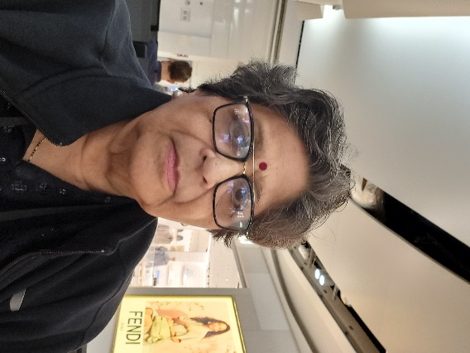
Ranjana Deshpande Muley: Now

Full Name | Yogesh Kumar Degan
Nick Name | --
Branch | Metallurgy
Email | yogeshdegan@yahoo.co.in
Phone | 916261587396
Current Location | Raipur
Educational Qualification | B.E.(Hons) Metallurgy, and after joining SAIL-Bhilai did Industrial Engineering.
Professional | * Apprentice Engineer at Simplex Casting Bhilai for 6 months after college in 1976  * Joined SAIL -Bokaro as Graduate Engineer on 1st March 1977.  * transferred to SAIL-Bhilai in October 1977 and continued up to 2011  * went back to SAIL-Bokaro as Executive Director Works in November 2011 and come back to Bhilai after 5 month .  * Superannuated from SAIL -Bhilai as Executive Director Works in September 2015.  * worked with Jindal Steel Plant Angul for 2 years as President ( Iron and Steel).  * worked with NMDC for 2 years as Advisor to CMD for Steel.  * After that associated with Almamet group ( a German company) as Advisor Technical
Family | My wife Mrs Rekha Degan also had a long teaching experience of Computer Science in various schools and colleges at Bhilai.  We have two children, daughter Anika did Engineering in Electrical from BIT Durg then MBA from US , happily married , staying in US for about 16 years returned to India and now at Pune working with Logistics group.  Son Ankit did Engineering from MIT Pune in Electronic and telecommunications and MBA from Canada. He is also married and after being in Canada for 4 years returned to India and now at Pune working in health sector.
Memory from College Days | In first year a young and energetic Mr Ghatage taught us Engineering drawing. In very first class he gave us a long list of instruments and things to procure, being very sincere students, many of us bought all the items but more than 50% of which were never used.  After many years I met him during a train journey, and we had good time chatting over his long list .

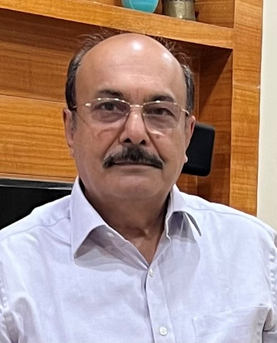
Yogesh Kumar Degan: Now

Full Name | R C Singh
Nick Name | Ram
Branch | Civil Engineering
Email | rcsingh846@gmail.com
Phone | 9826501633
Current Location | Nehru Nagar (west ) Bhilai (CG) India
Educational Qualification | 1. Higher secondary school certificate, from Higher secondary school Sector 7 Bhilai 2.Bachelor of Engineering (BE) Civil, from Ravishankar University Raipur.  3.Master of Technology (M.Tech) in Environmental Science and Engineering from Chhattisgarh Swami Vivekanand Technical University Bhilai  4. M I E of Institution of India  5. Chartered Engineer (India) .  6. Institution of Valuars .  7. Fellow- Member of Institution of India , Fellow No. F: 28515.
Professional | After passing engineering graduate ,I joined in private construction company Chopra Construction Co. I worked there for about one year as a Construction Engineer for machine foundation construction , levelling work, material management, Column and beam construction etc.  I applied for government job and selected in SAIL and joined and posted at Rourkela steel plant Orissa, India as a Management trainee . After one year training in different departments, I was posted in Traffic and Raw materials Department. I learned there about laying of railways rails, maintenance of rails, rails management etc. Then I was posted in construction Department. I constructed residential houses for the employees of Rourkela steel plant, office building etc. Then, I was posted in Barsua mines, Tensa mines, Kalta mines of Rourkela steel plant as an in charge of mines construction department. I constructed residential houses for the employees of mines of Rourkela steel plant, office buildings, I completed a project for Laying of drinking water supply line of 200 mm diameter of MS pipe about ten kilometers long and with 600 meters altitude which included construction of intake well in river, water treatment plant, drinking water reservoir having booster pumps for climbing the water for the Tensa township and offices . This project was completed within stipulated time, and I received appreciation from managing director of Rourkela steel plant. I constructed approach road to mines, culverts etc.  Then , after getting promotion of divisional Engineer,I got transferred from mines and posted in design department Rourkela steel plant as design engineer. I completed so many design for columns, beams ,slabs etc. After that, I got transferred from Rourkela steel plant to Bhilai steel plant and posted as divisional Engineer in Town Engineering Department for construction of residential houses as being funded by HUDCO. I constructed HIG houses ,MIG Houses and handed over the same to the individuals , I did maintenance of residential and office buildings , construction of roads, maintenance of sewerage treatment plant , laying of sewer lines. Etc.  After that I was posted in Construction Department, and I did so many small and big  projects e.g. Renovation of blast furnace, Renovation of power plant , construction of electrical gallery for power plant , construction of weigh bridges on railway lines of Bhilai steel plant, construction of office building, machine foundations , Construction of roads, laying of railway lines. Administration of projects etc.  I retired as Chief Engineer from Bhilai steel plant. After that I joined a private educational institution and posted as Head of Department of Civil Engineering. There l taught the civil engineering students from first year to final year students. I was there about 9 years and gave good results every year.  Lastly, I am with social associations and organizations and doing the social activities and will continue.......
Family | My wife - Mrs. Pushpa Singh  Education : B A, M A (Economics) from  Jabalpur University  Home maker and join with  N G Os. and social  Organizations and doing the  Social activities .  My daughter - Mrs. Nidhi Singh  Education : I I T in Computer science  from I IT Delhi  She is married and staying in  USA.  My son : Mr. Anubhav Singh  Education: M Tech. in Instrumentation &  Control from Bhilai Institute  of Technology.  B Tech in Electronics and  Communication from Bharati  Vidyapeeth's College of  Engineering, New Delhi.  Doing his own business in  India.  My daughter- MBA (HR & Finance), M.Com,  In law B.Com, DCA from CSVTU  Bhilai  Doing job in School
Memory from College Days | 1. I was from Bhilai and more students were from Bhilai. We Bhilaians came every Saturday from college hostel to Bhilai. On Saturday only one time food was used to prepare at noon only. Every Saturday, there was half day in college. On one Saturday ,during the meal some students got competition that who will eat more poori. So , many students started eating. Cook was surprised to see that. At last, three students ate a big amount of poories. The student who became first , ate 50 poories, second ate 45 poories, and third was me ate 35 poories. Second day, our stomachs became upset, and we were in pain. So that was a memorial moment for all of us.  2. We Bhilaians used to go on Monday from Bhilai to Raipur, to our college by train. The train time was at 8.45am starting from Durg station and reaching Raipur station at 9.45 am. All students generally used that train. One Monday, there was a magistrate checking. All the students climbed up the train. Nobody knew about magistrate checking. Most of the students were without ticket. So , between Kumhari station and Raipur, many students were caught by railway Authority. They were taken to the court in police van. The magistrate saw all the students and asked some questions and freed them by giving warnings not to do this in future. That day , those students could not attend the college. This was a very Memorial Day for them. Those days were students' days. Really, the student’s life was a unique life.

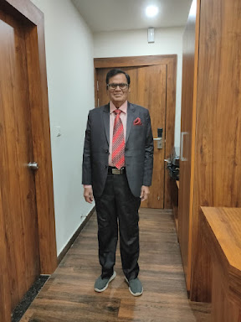  R.C. Singh: Now |  | 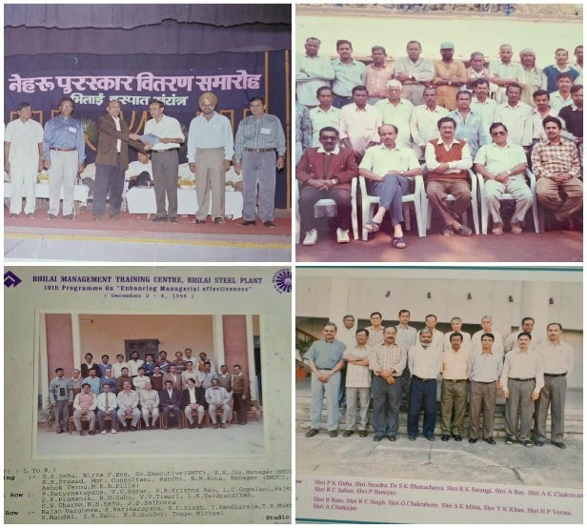  Top (Left): I received Nehru Puraskar for good progress & good time management  Top (Right): Safety Day Occasion  Bottom (Left): Program on Enhancing Managerial effectiveness in Bhilai steel plant.  Bottom (Right): Communication and presentation Skills conducted at management training institute ,Ranchi
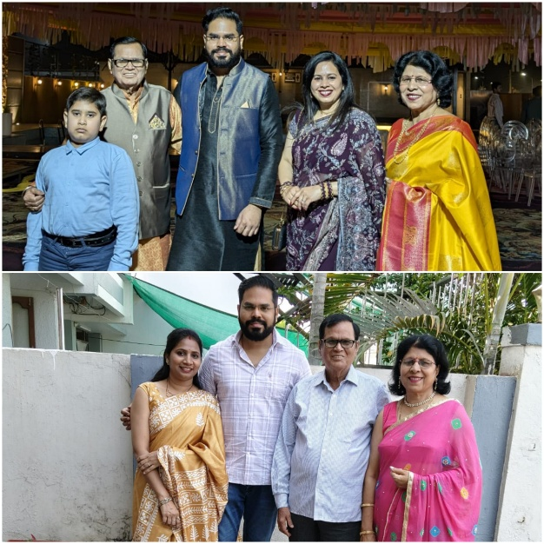  Top: Grandson, myself, son, daughter and Spouse  Bottom: Daughter- in- law, son, myself and Spouse |  | 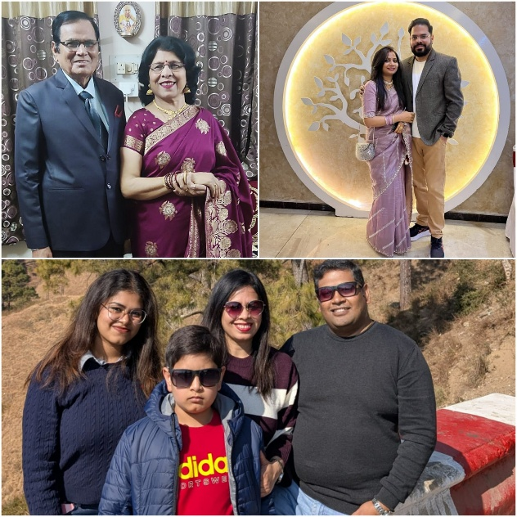  Top: Myself, Spouse, daughter-in-law and son  Bottom: Grand-daughter, grandson, daughter and son-in- law
Full Name | Ramkumar Jaggi
Nick Name | Raje
Branch | Mechanical
Email | rinvest2001@rediffmail.com
Phone | 8718011772
Current Location | Raipur, India
Educational Qualification | B.E. Mechanical
Professional | As uploaded with our photographs , please refer that
Family | As uploaded with our photographs , please refer that
Memory from College Days | --

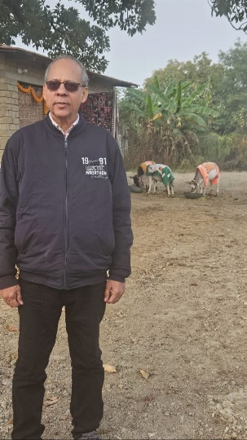  Rajkumar Jaggi: Now | 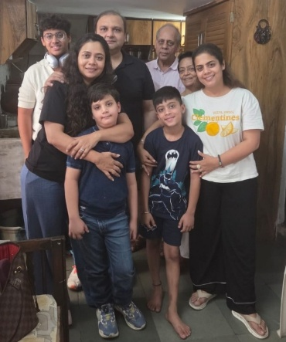  During recent Aditi’s visit to Raipur, the whole family gathered to have a wonderful Nani House time
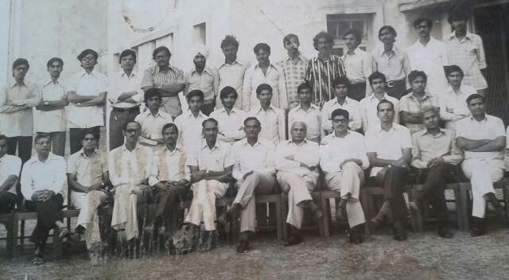  Photo was taken in the final year in college along with teachers and Batch mates a loving memory | 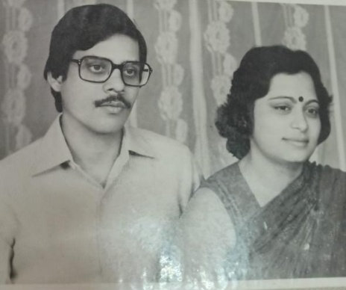  Photo taken of me and Suman just after marriage
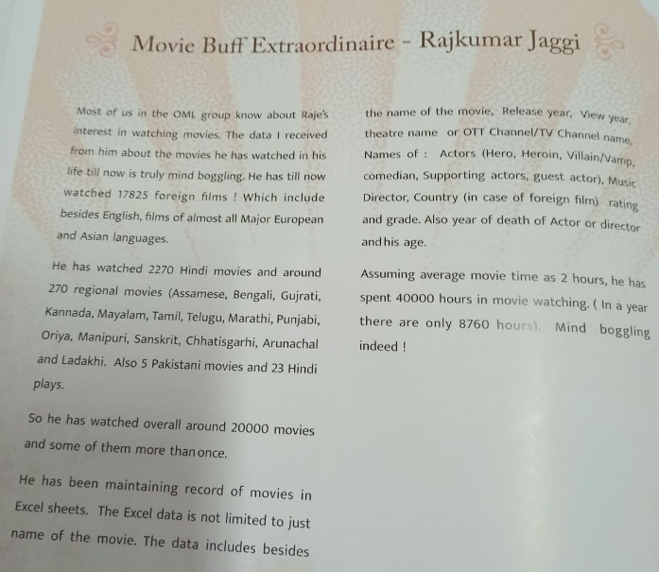 | 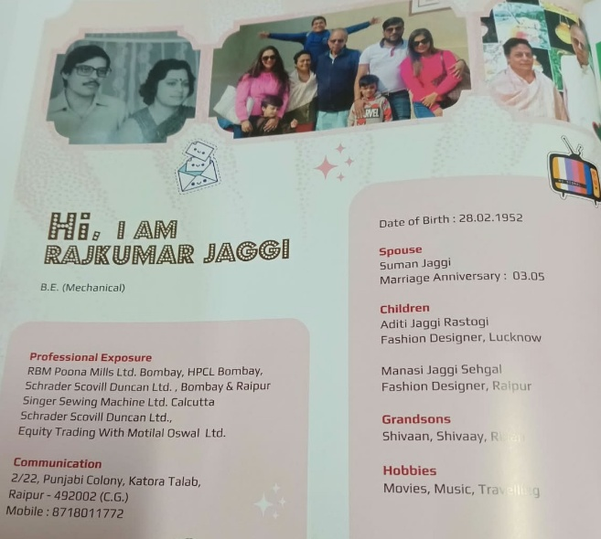

Full Name | Saibal Roy
Nick Name | Bachcha
Branch | Civil Engineering
Email | esskayare@gmail.com
Phone | 95654 44478
Current Location | Lucknow, India
Educational Qualification | I completed my BE ( Civil) with Honours in 1976 securing 4th Rank. I pursued my higher studies and obtained my M Tech in Soil Mechanics and Foundation Engineering from I.I.T Delhi in 1987 while working with CCI. My Post Graduate dissertation " Effect of varying Reservoir Levels in Koyna Dam using Finite Element Method( FEM) " reflected my interest in advance Geotechnical analysis and Engineering applications.  In the year 2000, I also completed the Lead Assessor Program for ISO Certification. I am a life member of Indian Geotechnical Society and a member of ISSMFE and have contributed a few Technical Papers in Professional Publications.
Professional | My professional journey spans nearly 46 years encompassing challenging assignments in Hydropower, Engineering Design, Industrial Projects ,Highways and in Real Estate.  I began my career with NHPC where for 4 years I was associated with the Construction of Head Race Tunnel for a Hydropower Prohect in Manipur employing New Austrian Tunnelling Method ( NATM) ,being used in India for First time working through extremely soft clayey and gassy strata in association with Austrian and German Consultants. It was very demanding and enriching Engineering experience.  I subsequently joined Cement Corporation of India (CCI) , spending 7 years in its Design office and progressing from Senior Engineer and then Dy Manager level.  My next 5 years were with RITES ,where I worked as Project-in-Charge in the rank of DGM, where I handled Coal Transportation System for Super Thermal Power Project .  Next 10 years were spent in MECON in Project Management Consultancy for Major Industrial Projects besides gaining experience in Contract Management.  I opted for early retirement as Additional General Manager (AGM) for a tryst with Private Sector.  Thereafter I spent 5 years as Project-in-Charge from Executing Contractors side working on major Highway Projects of NHAI in Bihar, Assam and Rajasthan.  After shifting to Lucknow, I spent nearly 15years overseeing Construction of High Rise Towers up to 25 stories at Senior Level in Real Estate Sector.  I retired as Senior Vice President of a leading Delhi based PMC and Infrastructure Consultancy Company.  Post retirement I did a few Consultancy assignment in Hospitality sector and also served in Expert Committee examining failures of some Highway Projects.
Family | I got married to Kakoli in 1991and together we have built a happy and close knit family. Kakoli is a Postgraduate in English with B.Ed. and was a Senior Lecturer at La Mariniere Girls College ( LMGC) Lucknow.  A gifted orator and keen enthusiast of Debates, she has always been a wonderful companion, whose charming personality has added warmth and joy in our journey together. She is also associated with ISC evaluation committee as a Team Leader for English.  Our only child our daughter is an Engineer and MBA working with a US based Multinational in Healthcare and Pharmaceutical Consultancy in Gurgaon.  Our Son in Law also an Engineer and MBA is working for one of the big Four in Management Consultancy Company in Gurgaon. We are blessed with a happy, loving and close knit family.
Memory from College Days | My college days remain among my fondest memories. On the very day of admission, I had my first taste of college life when Seniors of 4th year ragged us but with a light banter in College Canteen.  Facilities at Hostel was very basic with rather shabby toilets but the camaraderie made up for everything. We were fortunate to have some excellent and caring teachers like Prof Pilliwar and Prof Vachchani. Prof Pilliwar nicknamed me as " Bachcha". Mass bunking of Classes was quite in fashion till 3rd year to watch Block Busters of that era.  Looking back those simple moments of friendship, mischief, learning and adventure remain unforgettable.

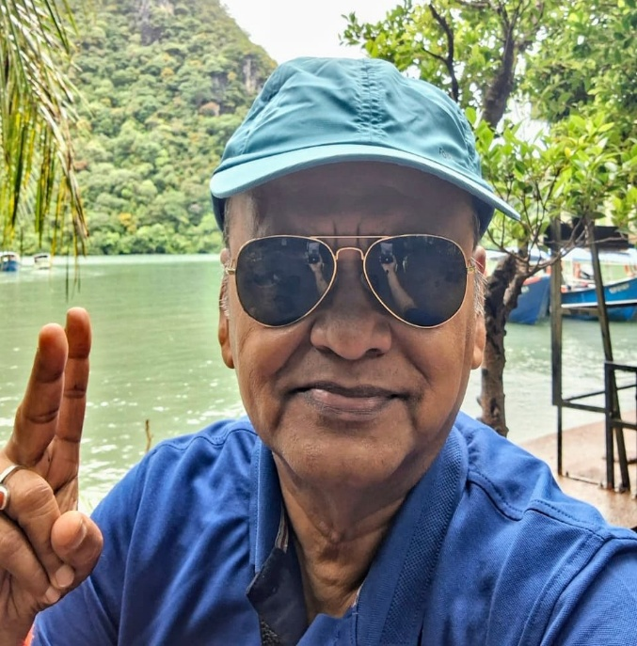  Saibal Roy: Now | 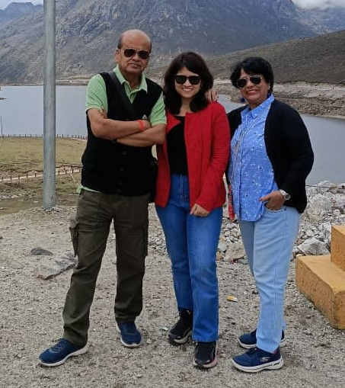  At Sela-pass Arunachal with my daughter Amrita and wife Kakoli
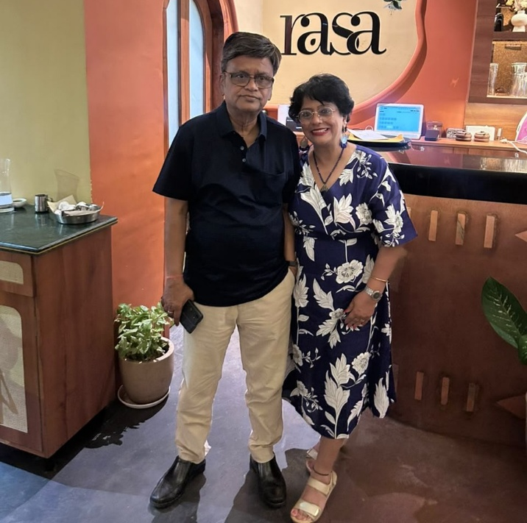  This Birthday with my wife | 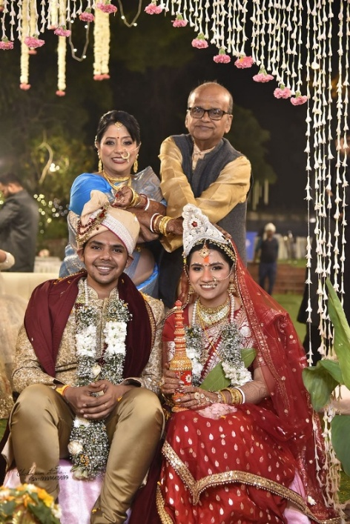  At my daughter's wedding in Delhi

Full Name | Sunil Agarwal
Nick Name | Sunil
Branch | Mechanical
Email | sagarwal1955@gmail.com
Phone | 9717645007
Current Location | Raipur, India
Educational Qualification | B E ( Mech) ( Hons)
Professional | Initially selected with Rank 2 in India in IES. Subsequently joined Indian Railway Traffic Service through IAS exam 1978. Worked as an Operations Manager in several imp locations and played an imp role in the growth of Indian Railways. Retired in 2015 as Additional Member Rly Board. , a rank equivalent to Chief Secy of a state.
Family | Married in 22Jan 1980 to Rachna who comes from Bhilai. My elder daughter Nidhi stays in Gurugram and is married to Anupam who is CFO of Devyani International. My son Gaurav is B.Tech. from IIT Bombay. After a few years stint as an investment banker , he now operates his own industry in Bhilai manufacturing specialized Ferro alloys. Both the children have two sons each.
Memory from College Days | Unfortunately, being a day scholar, I missed the fun and adventure of hostel life. Being English educated I got a head start in absorbing the lectures vis a vis my Hindu medium but more intelligent colleagues. Capitalizing on this advantage and constant push from my family, I topped all five years in College. An interesting incident was skipping college for four days to watch India - West Indies match in Nagpur with many class friends. It was a super experience having seen top international players at close quarter.

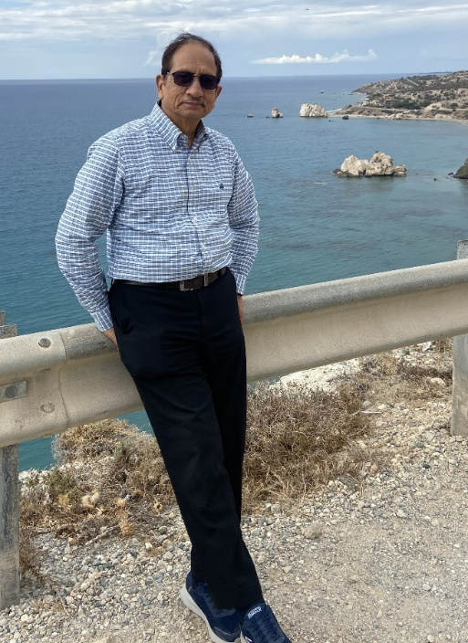  Sunil Agarwal: Now | 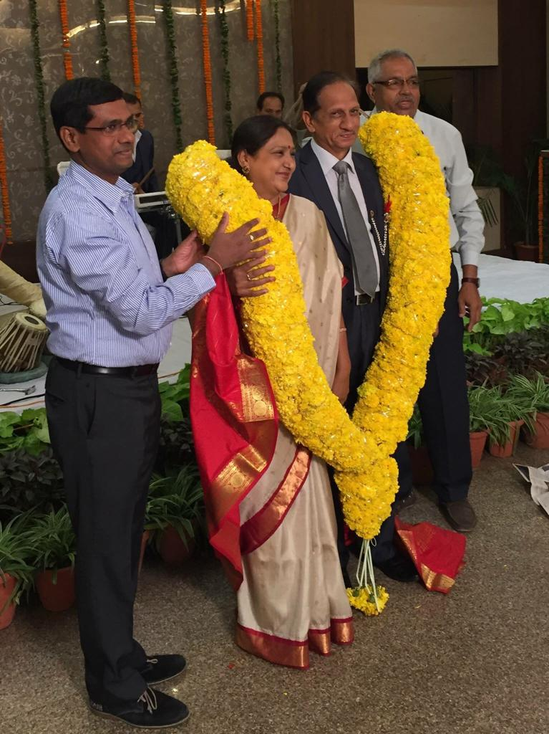  She is Rachna, my better half
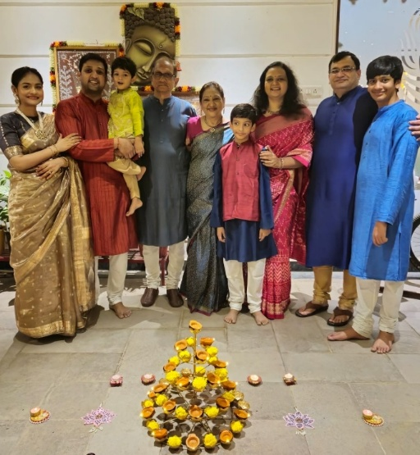  Our full family | 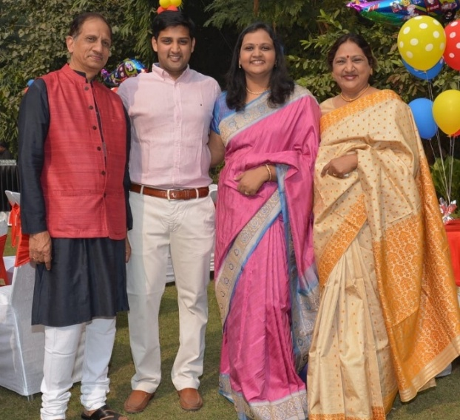  With son and daughter

Full Name | Narendra Thakkar
Nick Name | Narendra
Branch | Mechanical
Email | thakkarnk@gmail.com
Phone | 9425552425
Current Location | Bhilainagar, Durg, Chattisgarh, India
Educational Qualification | B E (Hons) Mechanical
Professional | One year as a trainee engineer in Dharamsi Morarji Chemicals, Kumhari, then from 27.09.1977onwards worked in Bhilai Steel plant till retirement on 30.09.2014
Family | Wife Rita and 2 Sons . Elder son Abhishek , web designer, his wife Aarti a kathak dance teacher blessed with a grandson Vyom and younger son Aniket , Marketing head , his wife Siddhi a software programmer, blessed with a grandson Augustya. All in Bangalore.
Memory from College Days | A loud applause when awarded Best Actor in Play College sutram directed by Rajesh Pathak sir

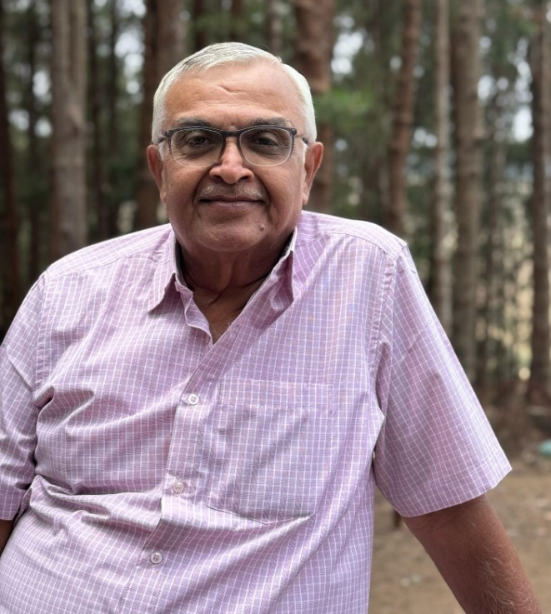  Narendra Thakkar: Now | 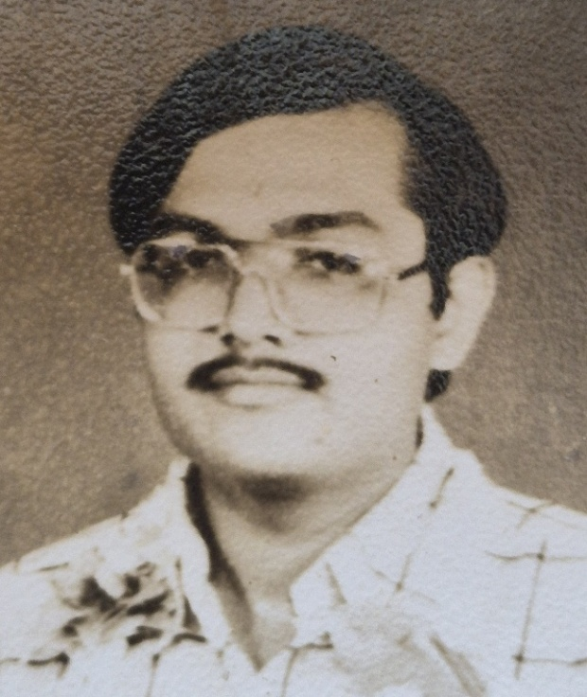  Narendra Thakkar : Younger days
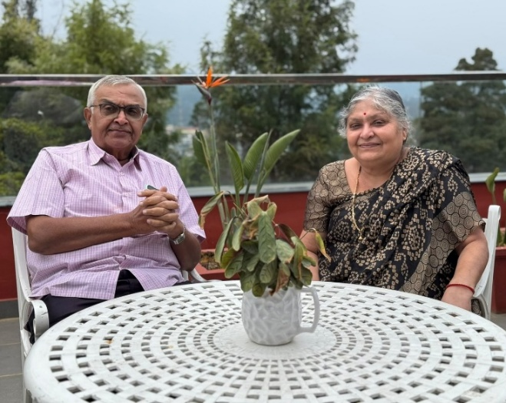  Relaxing at hill station | 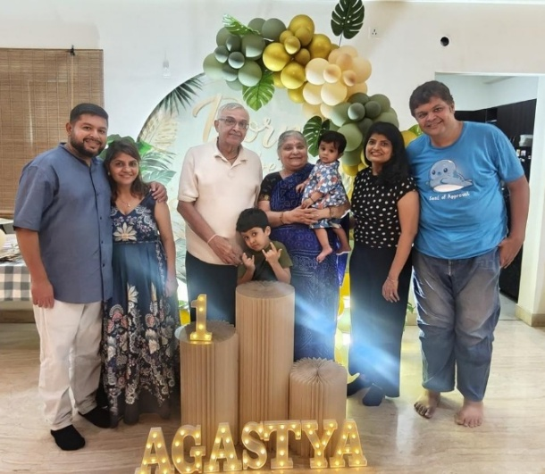  My family is celebrating youngest grandson's birthday 🎈

Full Name | Dewendra Mishra
Nick Name | Kishore
Branch | Civil
Email | dewendramishra01@gmail.com
Phone | 9425234425
Current Location | Bhilai, Chhattisgarh
Educational Qualification | Civil engineering from GCET Raipur
Professional | Five years in Madhya pradesh irrigation department after that civil engineer contractor at BSP ,PWD and HSCL .
Family | In my Family I have a spouse and four sons .
Memory from College Days | In my college days, I performed a Bhojpuri song " Piya morre balak mein taruni" and I received a reward named as Swar Madhuri.

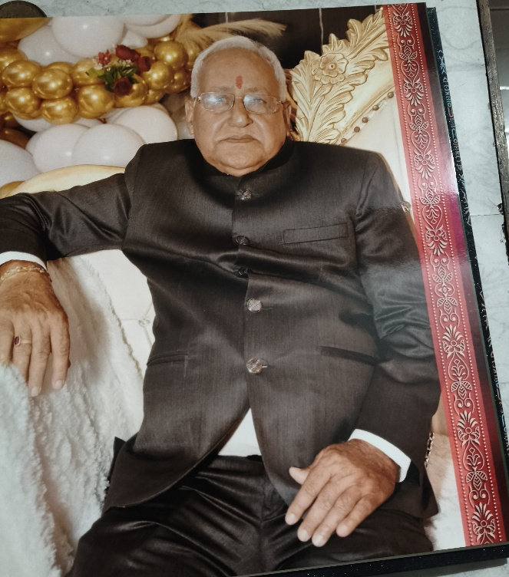  Dewendra Mishra: Now | 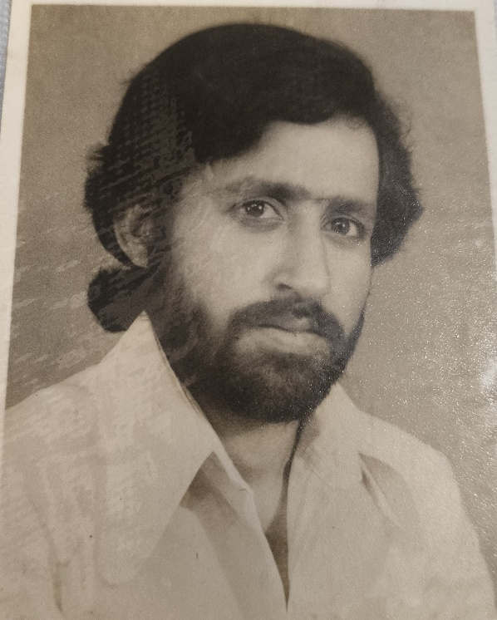  The Photograph is of final year in college
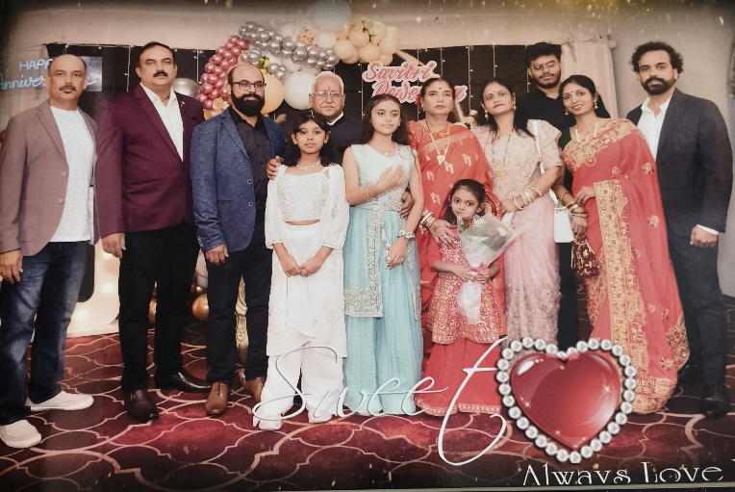  Family meet on the occasion of my 50th marriage anniversary | 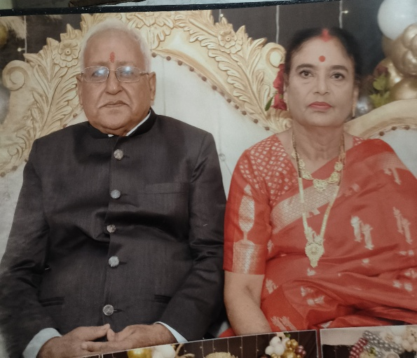  With my spouse on occasion of our 50th marriage anniversary

Full Name | Satish Rawat
Nick Name | Satish
Branch | Mechanical
Email | satishrawat53@gmail.com
Phone | 9826442234
Current Location | Bhopal, India
Educational Qualification | Bachelor of Engineering (Mechanical)
Professional | I served in Madhya Pradesh P.W.D. (Elect & Mech) and retired in 2013 as Superintending Engineer. I look after all Mechanical repair works of all types of plant and machinery involved in road and bridge constructions including automobiles. I also execute and supervise electrification of all Govt buildings including substations, lifts and central air conditioning.
Family | My wife Meera manages home, and my elder son Rahul Khandelwal is IT engineer and working in Capgemini Mumbai as Sr Director cum Chief Architect. My daughter Megha Khandelwal is also IT engineer and working in Meta Inc, San Francisco (USA) as Senior Manager.
Memory from College Days | Though I was in Mechanical Engg., but in college library I love to read electronics books. I love to assemble and make transistor radios.

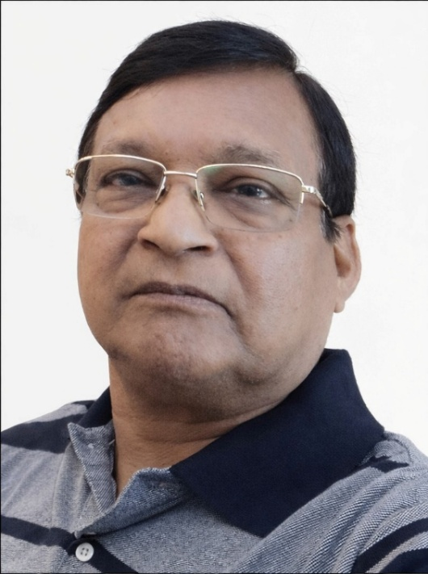  Satish Rawat: Now | 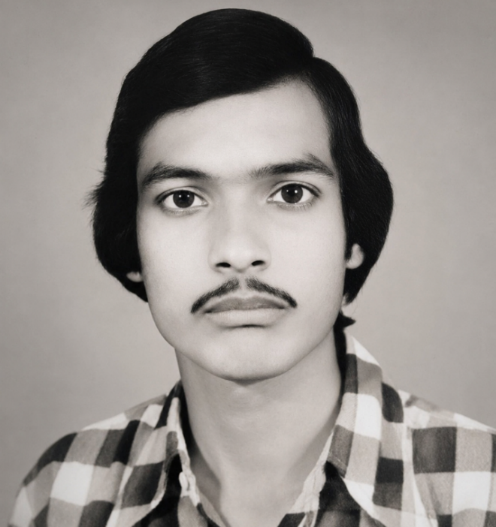  Myself after 9 years in 1985
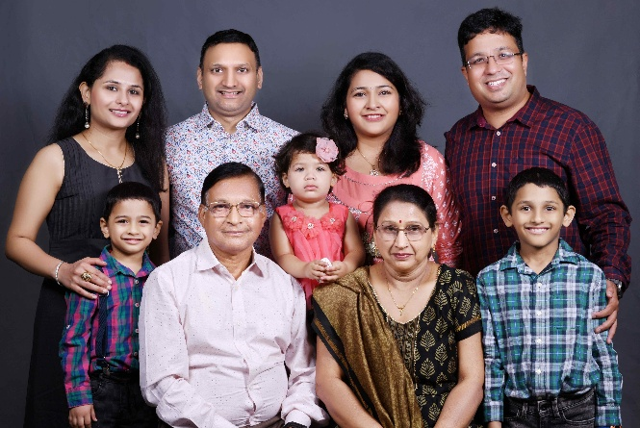  Me and my full family with grandchildren | 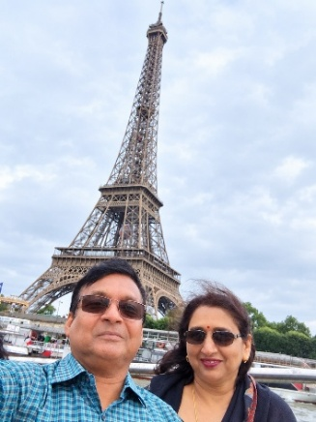  In Paris in 2016

Full Name | Subodh Kumar Verma
Nick Name | Subodh
Branch | B. E. (Mechanical)
Email | subodhv2003@gmail.com
Phone | 9892274074
Current Location | Mumbai, India
Educational Qualification | Bachelor of Engineering (Mechanical)
Professional | AIR INDIA ( From 1978 To 2011)
Family | Wife- Poonam Verma, MA, B Ed, a retired school teacher in Mumbai.  Served for more than 36 years.  Two Daughters-  Shweta Verma (B. Tech, MBA-USA),  Married and settled in USA  Swati Verma (B.Tech, MS-USA).  Married and settled in USA
Memory from College Days | --

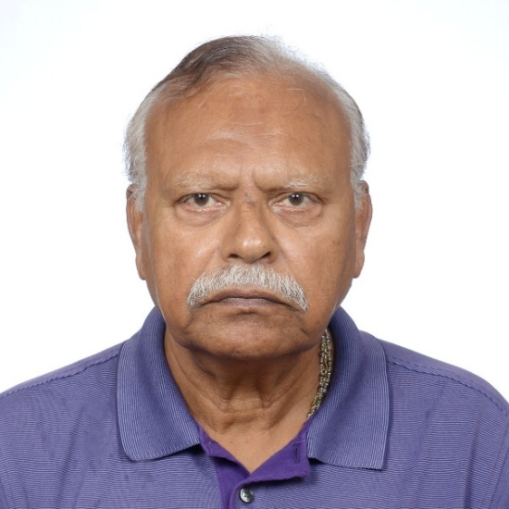  Subodh Verma: Now | 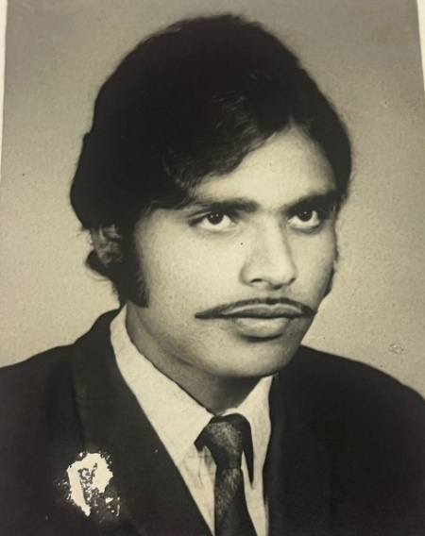  Subodh Verma: Then
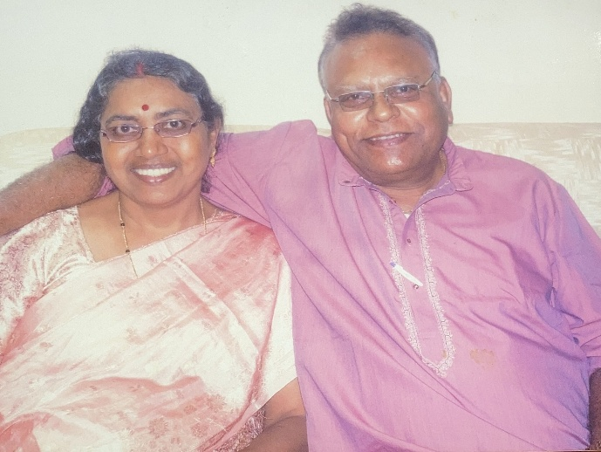
With my wife

Full Name | Uday Vadavi
Nick Name | Vadavi
Branch | Metallurgy
Email | udayvadavi@gmail.com
Phone | 9148139535
Current Location | Belgaum (Karnataka)
Educational Qualification | B.E ( Metallurgy)
Professional | Joined Bokaro Steel Plant, SAIL in 1978 and left in early 2003 to join Mittal Steel Annaba, Algeria. Transferred to Mittal Steel Galati ( Romania) as General Manager and then became Director ( Investments) in Arcelor Mittal Ostrava (Czech Republic). As CTO , Algeria, completed a one billion dollars project in record time and rejoined AM Europe, Business Division East as Head of Engineering. Took retirement in 2018& now engaged with couple of companies as Advisor
Family | Wife Bharati and 3 children, 2 daughters and a son. All settled in Bengaluru
Memory from College Days | I was poor in Mathematics, and my roommate Vijay was a mathematician, who taught me the basics and then I got the rough class notes of Sunil( Agrawal) and in two efforts cleared the first year!!

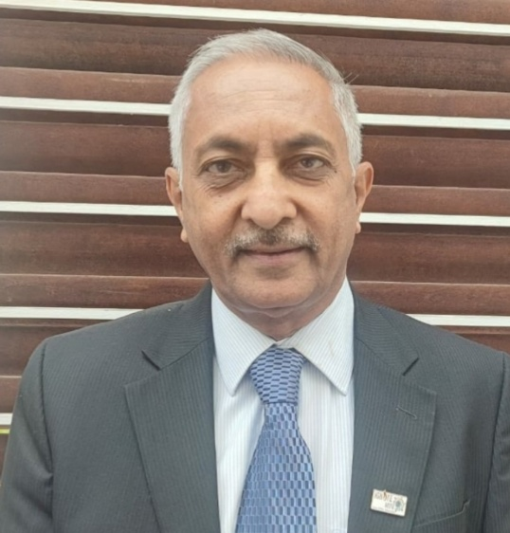
Uday Vadavi: Now

Full Name | Dhruwadeo Prasad Kushwaha
Nick Name | Dhruwa
Branch | Metallurgy
Email | dhruwadeo1954@gmail.com
Phone | 8435176368
Current Location | Bhilai (C.G ) ,India
Educational Qualification | B.E ( Metallurgy)
Professional | In my early days, I worked at the Bhilai Engineering Corporation's melting shop (which housed an electric arc furnace).  Subsequently, I worked at Sinter Plants 1, 2, and 3 of the Bhilai Steel Plant.  After retiring from the Bhilai Steel Plant, I worked for a time at Sunflag Iron and Steel Company.
Family | have two children: a son who is married and works at the JSW Dolvi Plant—he has two children, a daughter and a son—and a daughter who is married and a homemaker; my son-in-law works at NALCO, Angul.
Memory from College Days | --

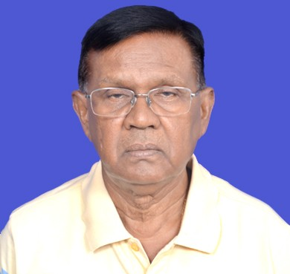  Dhruwadeo Prasad Kushwaha: Now | 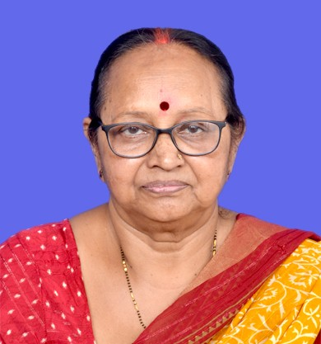  My Wife
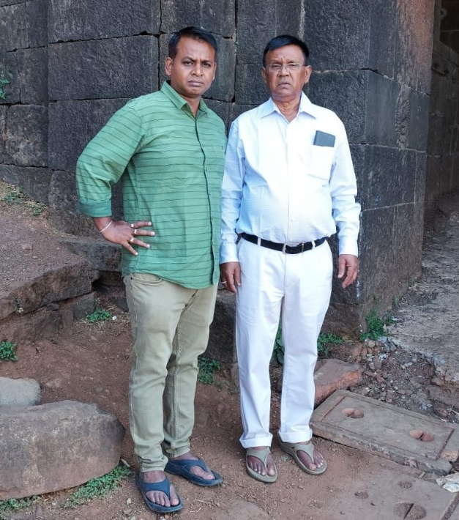  With my son | 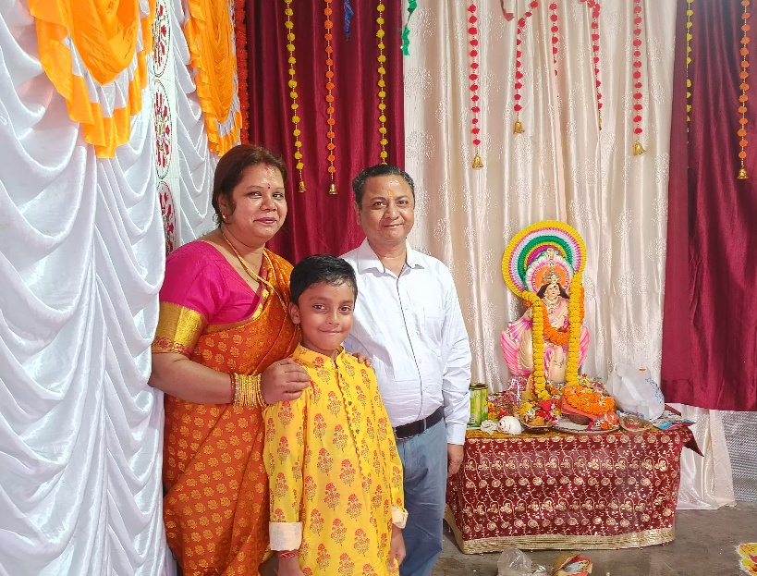  My daughter, son-in-law and grandson
`
Full Name | Kabir Ghosh
Nick Name | --
Branch | Mining
Email | kbirghosh@gmail.com
Phone | 919928906050
Current Location | Kolkata
Educational Qualification | 1. BE( Mining)(Hons) 2. First Class Mine Manager Certificate of Competency (Unrestricted)3. Advance course on mining technology, Lulea University of Technology, Sweden 4. Short term courses on Management at IIM Ahmedabad
Professional | After a brief stint in Singreni Collieries, I joined Hindustan Zinc Ltd in Nov 1976. This company was later taken over by Vedanta ( earlier Sterlite) I continued my professional journey in the same company and finally retired as Vice President & Head - Technical in June 2015. During my tenure in the company i visited number of countries namely Sweden, Norway, France , Austria, Spain, China, Australia, South Africa , Zambia, Indonesia basically for bringing in best of underground mining technology in our mines.  After retiring from Vedanta I joined Teknomin Construction Ltd and still continuing ( A mine development Company ) as director. Parallelly working as underground mining consultant . I worked as consultant for Adani Enterprises, KPMG and at present senior consultant of Indias first private sector Gold Mine operator M/S Geomysore Ltd
Family | My wife Bratati is a home maker born and brought up in South Kolkata. She is masters from Calcutta Unveracity and also a degree in music. Only one son, a mechanical engineering graduate & MBA from Welingkar Mumbai. At present works related to finance and lives with us.  We three brothers graduated from this college, me in mining, Kanak in Metallurgy and Kamal in Mechanical.
Memory from College Days | --

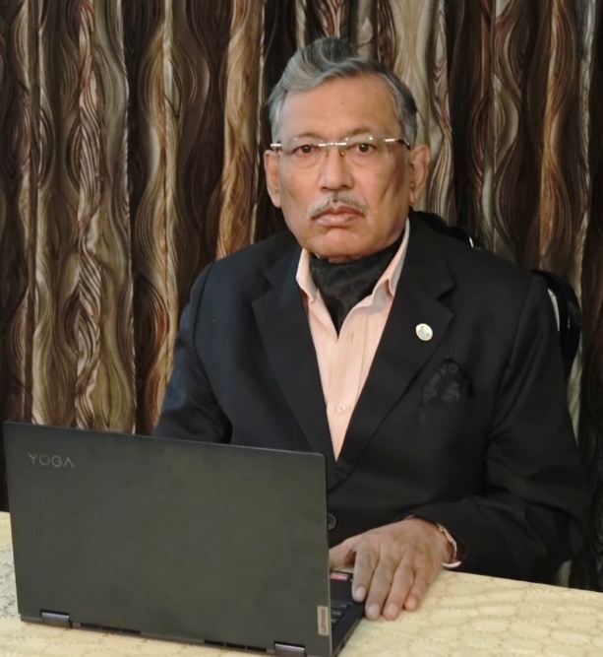  Kabir Ghosh: Now | 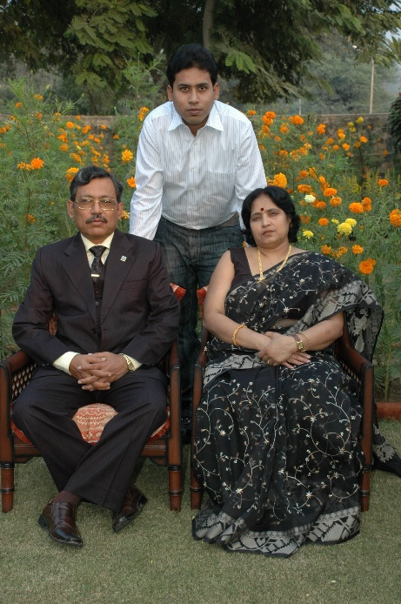  Myself, my wife and son
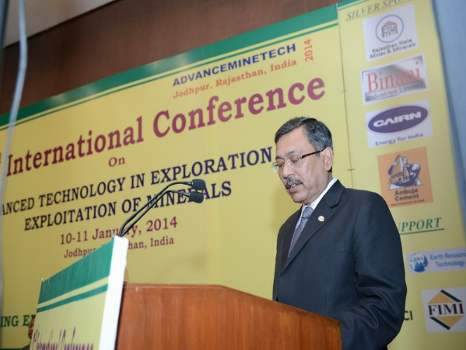  Presenting paper on advanced mining technology at International Mining Conference Jodhpur 2014 | 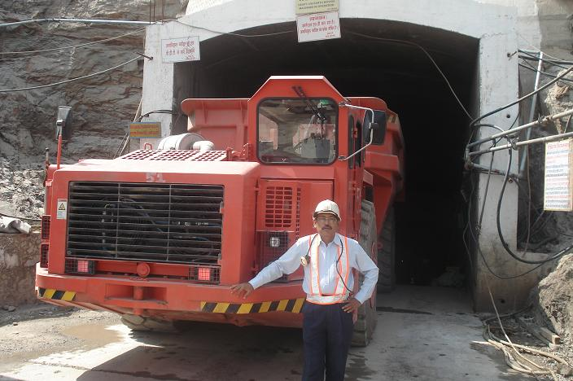  A Dedicated Miner

Full Name | Amol Kumar Sakalker
Nick Name
Branch | Mechanical engineering
Email | sakalkerak@gmail.com
Phone | 98694819645
Current Location | Pune, India
Educational Qualification | BE (Hons.) Mechanical
Professional | I started my carrier with Premier Automobiles Ltd. and then Jyoti Ltd. for very brief periods and then joined Bharat Petroleum Corp. Ltd. (BPCL) where I worked till retirement. Ours was the first batch after nationalization. The scenario was very difficult. Earlier crude was very cheap, leading to all the consumers becoming very lax on efficiency and lagging in proper usage of petroleum products. When OPEC was formed it gave shock to all the countries by forcing crude oil prices to increase 10 to 11 times. This led to throwing India in balance of payment crises. After joining we were given training and attached to a group formed by ministry named Petroleum Consumption Action Group (later known as PCRA). our task of how to increase efficiency of petroleum product consumption at the customer end. We carried out studies at all the large and medium industry and suggested ways to conserve petroleum products. Films, leaflets, posters and films were prepared, and seminars were conducted to create awareness among consumers.  Oil industry jobs are quite strenuous and involving. We are also frequently transferred from one place to another. I've worked in sales, customers service, safety audit, surveys at customer places for proper use and conservation of petroleum products. When I was posted at headquarters I was given all India upgradation of vehicle service stations at our petrol pumps. Which I was able to achieve at large number of locations. When I was in charge of lubricants at various locations, I was able to achieve very good sales performance against local and multinational enterprises. In my last posting I was assigned all India coordination of environmental projects. This included projects to enhance efficiency in all our activities including refinery, installations, depots and offices. We arranged third party audits of our activities. These were then becoming part of our Sustainability reports prepared every year. Then it is submitted for board approval to putting on the BPCL site for shareholders’ and public view.
Family | Oil company job was so involving that I was not able to give time to household jobs and contribute for children's growth. I give entire credit to my wife for virtually single handedly managing entire house matters. She did this job very well and now my children are well placed in their lives. My grandchildren are also doing very well in their academic, sport and extracurricular field.
Memory from College Days | Studies in NITRR being very engaging, most of my time was going in studies only.  Bicycle was my mode of transport for going to college and to city. In the evening virtually every working day I used to go and meet my batchmates. This was my only pass time in those days.  In school I used to play badminton and table tennis. Used to take part in various tournaments. After joining NITTR due to study pressure my sports and other activities were reduced.

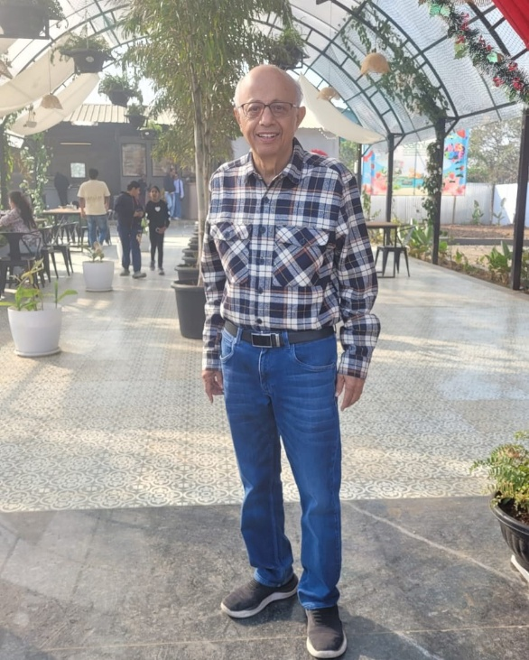  Amol Sakalker: Now | 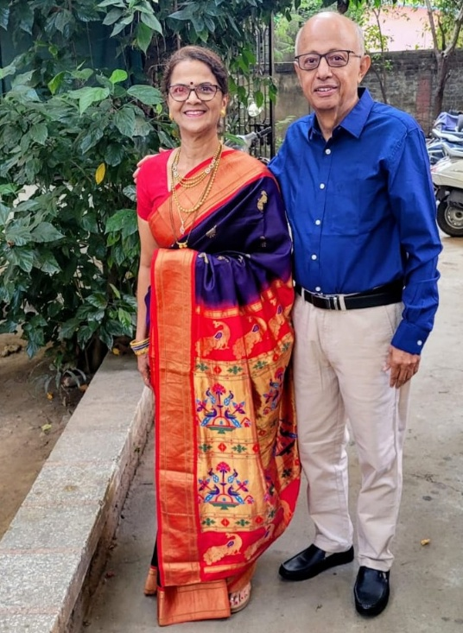  Photo with my wife Mrs. Chitra Amol Sakalker
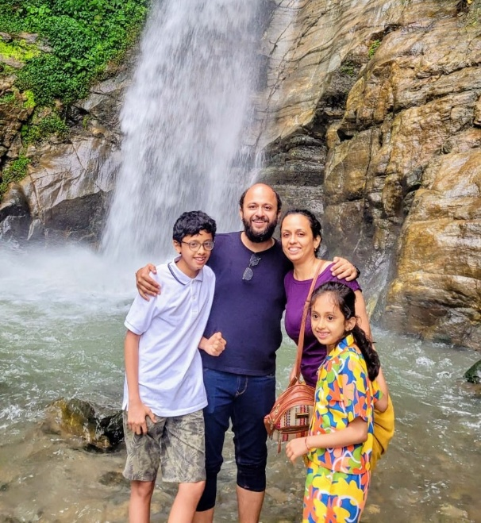  My son's family photo during visit to Dharmshala, Himachal Pradesh | 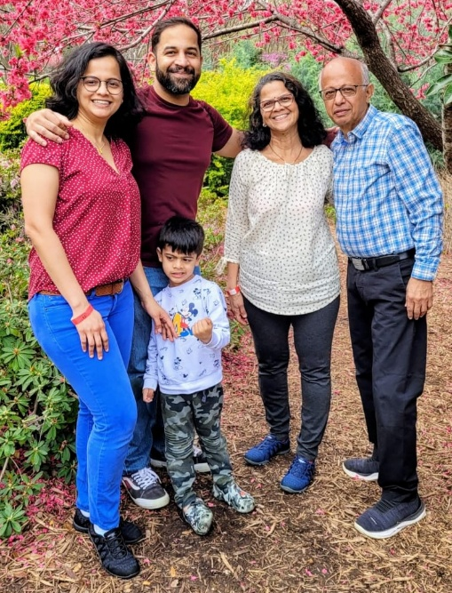  Photo with my daughter's family during our visit to Dellas, Texas, USA

Full Name | Santosh Golechha
Nick Name | Golu
Branch | Chemical Enginnering
Email | santoshgolechha1953@yahoo.com
Phone | 9826168811
Current Location | Durg Chhattisgarh
Educational Qualification | B E Chemical
Professional | After passing out college selected to self-business using the knowledge acquired in college. Select a less traveled field e.g. Recovery of valuable chemicals from factory waste. First started with Bhilai steel plant coal chemical waste. Work around 6 years with this. Meanwhile I came across waste from petroleum crude oil tank bottom Started working on that with ONGC Uran. Recovered a valuable product Micro crystalline wax. Which was raw material for cable jelly and being imported We have substitute that with our product We were supplying this product to almost all large cable jelly manufacturer For almost twenty years we were on this field. Due various safty norms we started looking new field. Then we came across waste from edible oil refinary. Which was a major pollution problem for them. We started making lubricants for PVC pipe extrusion Out of this waste we further develop Biofuel and marketing that a substitute for LDO for road making. Which has more calorific value than fossil fuel. I was deeply involved in social services. Worked with Viswa Hindu Parishad in various assignments for about 30 years Just relieved from Post of State President VHP. Chhattisgarh. I am strong believer in Bhartiya Sanskriti and like travelling and traveled entire Bharat and most part of world.
Family | Married Usha in 1980. She is from Indore I have two children one daughter Shivangi and son Aditya Shivangi is electrical Chandelier designer and manufacturer live in Mumbai. She is very well established in industry. Aditya is working with me. And taking over the charge of business and responsibility. I have two grandson Prithvi and Agustya. My daughter has two kids, Abhiraj and Shikha. I’m from large family that is well settled in Chhattisgarh in various cities. My residence is at Malviya Nagar Durg.
Memory from College Days | Initially I was not in Hostel. Doing up and down from city. I was not good in English, so classes were difficult for me as there was no English in village school. With friends’ help I could overcome the problem. Then in the final year, I joined Hostel life. I came across lot of other personalities. Since last ten years, we have been meeting 1977 batchmates and enjoy a week or more in some tourist place. It gives me new URJA to enjoy the life .

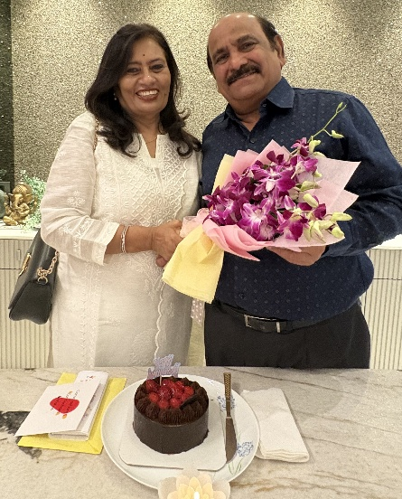  Santosh Golechha: Now | 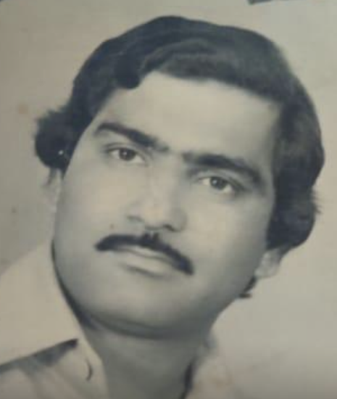  Santosh Golechha: Then
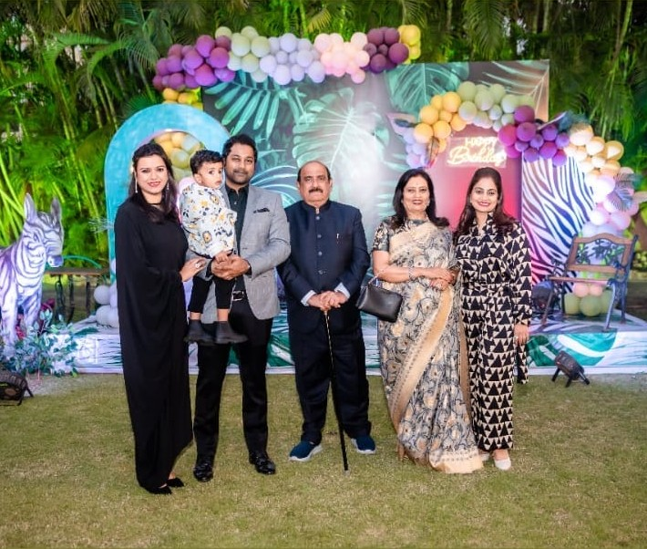  First birthday of my grand son | 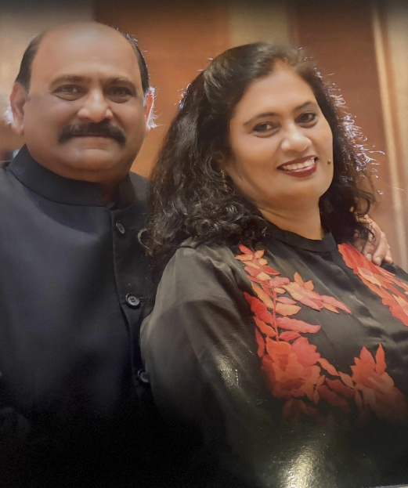  Myself with my better half Usha

Full Name | Avinash Pandey
Nick Name | Avinash
Branch | Mechanical
Email | avinash.pandey12@gmail.com
Phone | 8895501118
Current Location | Bilaspur, CG, India
Educational Qualification | Higher Secondary - Bhilai Vidyalay, Bhilai, 71  BE - GCE@T, Raipur, CG, joined in 71 and passed in 1977
Professional | 1) ACC as GOIT Trainee from Oct 77 till April 78  2) SAIL - Rourkela Steel Plant as Graduate Engineer, joined in May 78  3) worked as Mechanical maintenance executive in Coke Ovens Department of RSP  4) Changed to inhouse consultancy division of SAIL in 2000 till the retirement in 2015  Retired from SAIL, Rourkela in 2015 as Deputy General Manager (DGM)
Family | Married to Indu Pandey -- Dec 1982  Elder Daughter - Prachi Dixit  Younger Daughter - Shachi Pandey Tripathi  Both married  Elder Son in law - Kapil Dixit, Vice President in a startup, Gurgaon  Younger son in law - Gaurav Tripathi, Vice President, American Express Bank, Gurgaon  Have four grandchildren  Vedanshi - 12 yrs, Viraj - 4 yrs, Minerva - 4 yrs  Viansh - 4 yrs
Memory from College Days

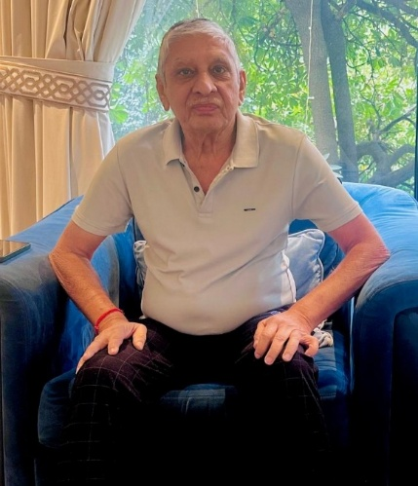  Avinash Pandey: Now | 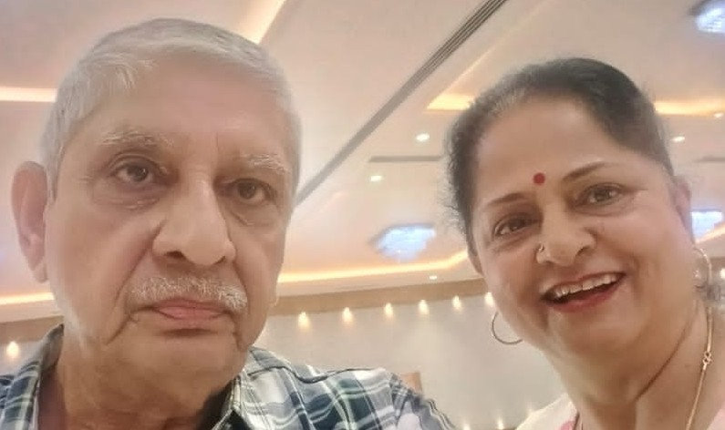  Myself and my life partner Indu
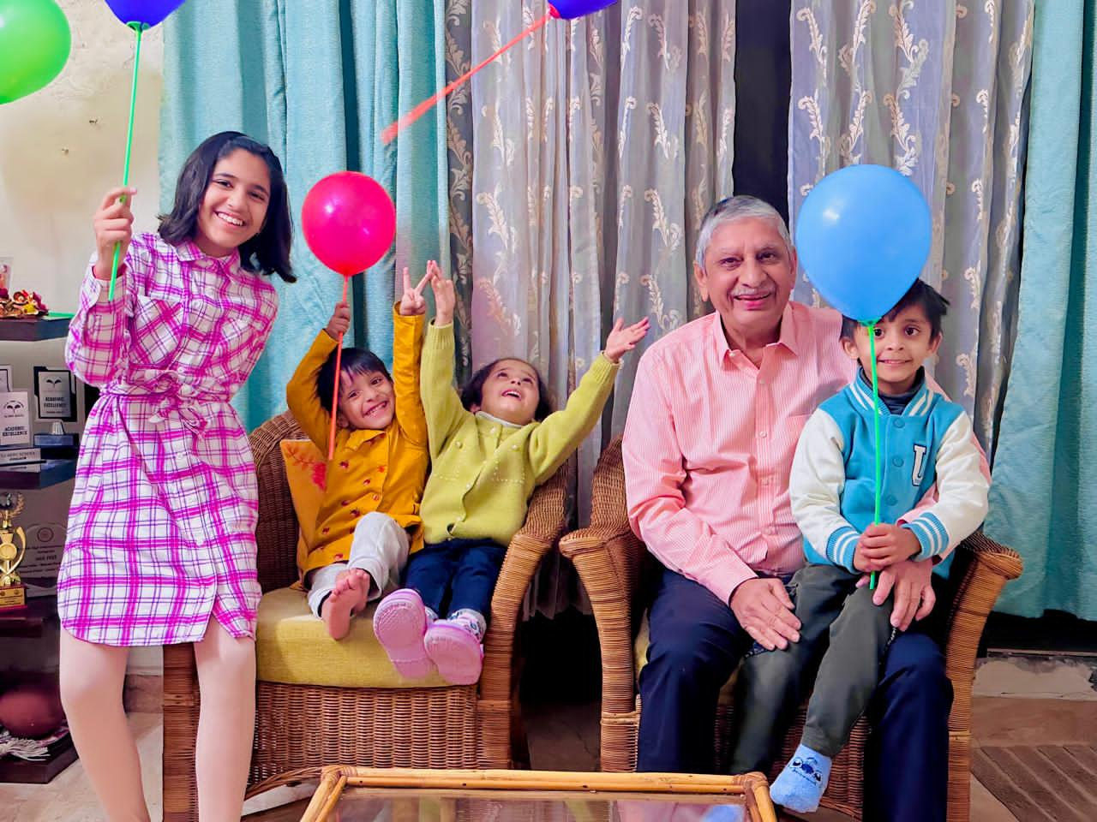
With grandchildren

Full Name | Umesh Chitlangia
Nick Name | Umesh
Branch | Mechanical
Email | president.gecnit@gmail.com
Phone | 9893122461
Current Location | BHILAI, CHAATISHGARH, INDIA.
Educational Qualification | I completed my Matriculation from "Sarveshwar Das Municipal School", Rajnandgaon (M.P.). I was a meritorious student and secured a place in the Madhya Pradesh Board Merit List in both the 10th and 11th Board examinations during (1969 - 70) & (1970–71.)  During my school years, I had the privilege of serving as the President of the Students’ Association, which provided me with an early opportunity to develop leadership, & organizational skills.  I belong to a family with a distinguished legacy of freedom fighters. This family heritage has deeply influenced my values of patriotism. Commitment to the society.
Professional | I am the Founder & Chairman of Polybond Group of Industries (C.G) and the Founder of Polybond Insulation Pvt. Ltd. Bhilai, established in 1995. The company specializes in the manufacture of Mineral/Rock/Stone Wool insulation products and solutions for Steel, Power, Refinery, Fertilizer, and other industrial sectors.  I am also associated with FairFlux Pvt. Ltd., a company engaged in the manufacture and supply of metallurgical products. And appreciated as best quality, ancillary unit to SAIL in year 2002.  My professional journey has been driven by a commitment to engineering excellence, innovation, and industrial development. I have contributed to collaborative innovation initiatives with CSIR and Tata Steel, particularly in the field of sustainable iron-making technology using industrial waste.  I was honoured with the "Engineer of the Year Award" – 2023 (Chhattisgarh State) in recognition of my contribution to the engineering and industrial sector.  Leadership & Social Contributions:  Founder & Chairman – Polybond Group of Industries, Rajnandgaon.  President – GEC–NIT Alumni Association, Raipur.  Past Chairman – CII, Chhattisgarh, state council.  Past President – Student Welfare Committee, GEC Raipur.(1975)  Past President – Rotaract Club of GEC Raipur (1976).  President – VWF Goshala at Rajnandgaon.  Engineer of the Year Award – 2023 (Chhattisgarh State).  Actively involved in industry development, engineering innovation, alumni activities, education, social welfare, and community initiatives.
Family | * We are blessed with a son and a daughter. Our son Rahul and his wife Rachana are settled in Bhilai with us, while my daughter Ruchi and her husband Tanmay are settled in Noida. We are also blessed with four grandsons, who bring immense joy and happiness to our family.  * Belongs to Freedom fighter Family  * One road “CHITLANGIA MARG” in RAJNANDGAON (C.G) is named in the memory of Grandfather with statue.
Memory from College Days | My journey with GEC/NIT Raipur began in 1971–72 as a first-year Engineering student. I proudly cleared all my subjects in the first year, writing my answer papers in Hindi, and those early college days became some of the most memorable years of my life.  Our hostel room was often filled with 8–10 friends, and we had turned it into our own little “Music Company,” with singers and instrumentalists. We were always ready for the Hostel Day and College Gathering—music, friendship and enthusiasm were part of our everyday life.  The college gave me not only engineering education and practical learning, but also lifelong values of, teamwork, social involvement and participation in various social programs, along with friendships in the life till today.  In my fourth year, I was chosen to take up the responsibility of President of the Students’ Union. During the period when the Emergency was declared, our Principal, Shri Deshpandey, called me and seriously advised me that, officially, I should introduce myself as the President of the Students’ Welfare Committee. This was another memorable chapter of my college life and gave me valuable experience in leadership, responsibility and working with students and the college administration.  After more than five decades, I feel immense pride and gratitude to remain connected with all friends, and also as the President of the GEC–NIT Alumni Association.  GEC/NIT Raipur is not just where I studied—it is where my professional journey, leadership experience, lifelong friendships and many cherished memories began.

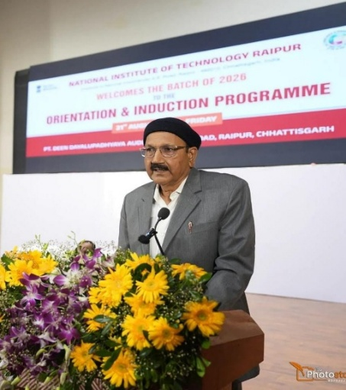  Umesh Chitlangia: Now | 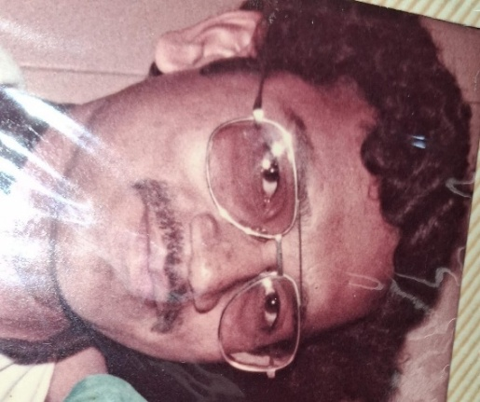  Umesh Chitlangia: Then
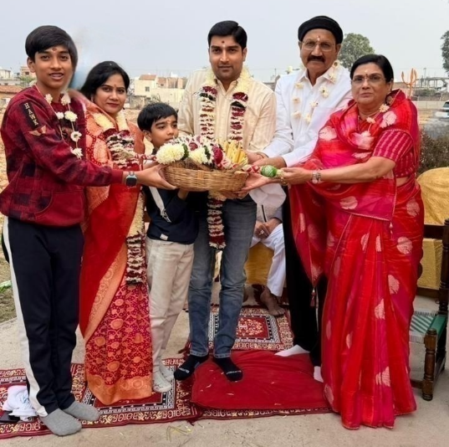  Umesh Chitlangia with family members | 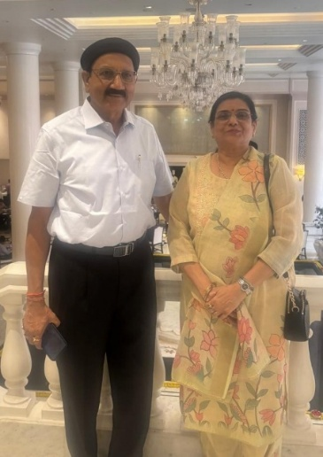  Umesh Chitlangia with better half

Full Name | Pinaki Sengupta
Nick Name | Pinaki
Branch | Civil
Email | pinaki2512@gmail.com
Phone | 9827187973
Current Location | Raipur India
Educational Qualification | B.E.
Professional | 1) Joined SADA ( Special Area  Development Authority) Korba August 76  Left SADA Oct 79  2). Joined Pvt construction company working for NTPC. Korba  3). Joined MPEB in 2008  posted at Sarni, Korba, Raipur ( HQ),  Gangrel ( hydro power project)  Retired from CSPTCL (CS Transmission Company ) as Add. Chief Engineer in December 2012.  Now settled at Raipur
Family | 1). Married 1985  2) Two daughters, both working at  Mumbai
Memory from College Days | --

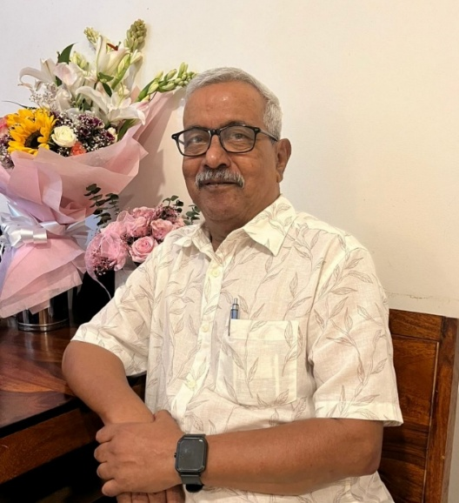  Pinaki Sengupta: Now | 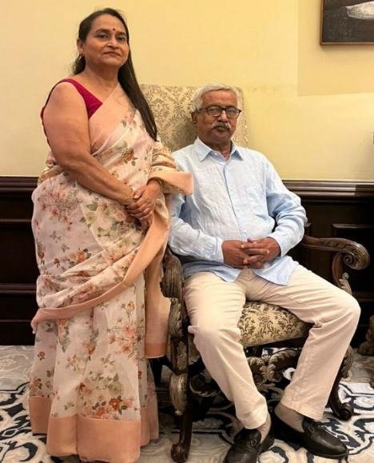  Pinaki Sengupta with better half
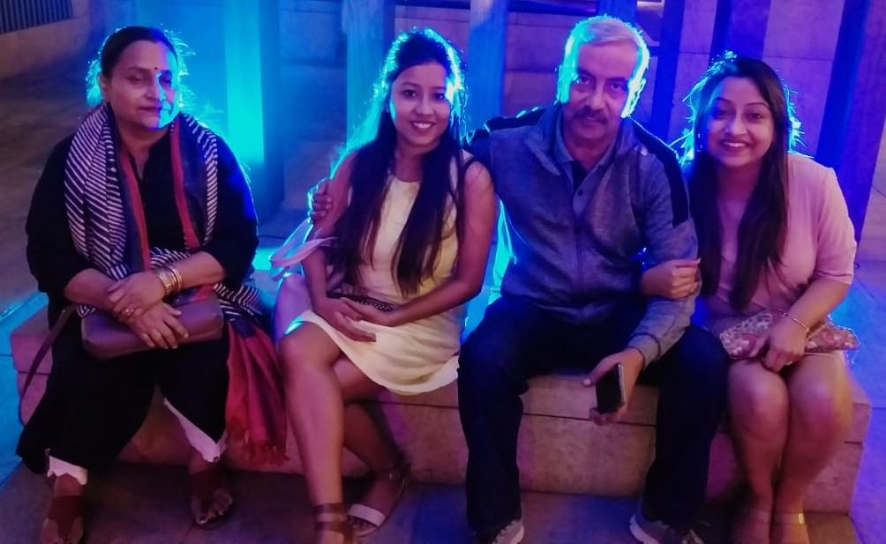
Pinaki Sengupta with family members

Full Name | Avinash Kumar Verma
Nick Name | Verma
Branch | Mechanical
Email | aviverma1955@gmail.com
Phone | 9285100891
Current Location | Bhilai, India
Educational Qualification | B.E. (Mechanical), Industrial Engineering, AIMA Diploma, Energy Auditor, Fellow Institution of Engineers
Professional | Total Service: 37.5 years with SAIL  Project Department:28 years across various sections of BSP/SAIL  Vigilance: Last 9.5 years in Vigilance, serving at BSP and CFP, SAIL
Family | Married for 42 years to Dr. Swarn Lata Verma, a retired Professor from Mahila College, Bhilai.  Blessed with two daughters: Radhika Verma, based in Sydney and working as a Cyber Security Professional. Her husband is a Manager and AI Lead at Capgemini.  Proud grandfather of two grandsons, Ranvit and Ashvik.  Younger daughter, Ramya Verma, is based in Delhi and works as Legal Counsel with Air India.
Memory from College Days | While conducting a Chemistry practical, Prof. Joshi noticed our difficulty in spelling the word “effervescence”. With his characteristic wit, he remarked: “जब ‘Effervescence’ की स्पेलिंग नहीं आती, तो क्यों नहीं लिखते—बुदबुदाहट होती है!”

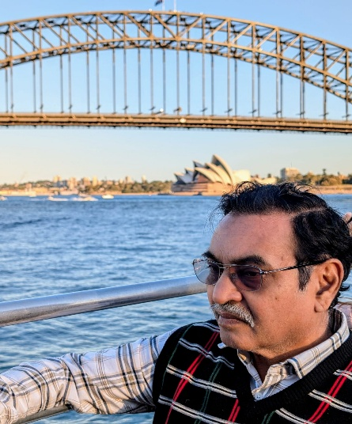  Avinash Kumar Verma: Now | 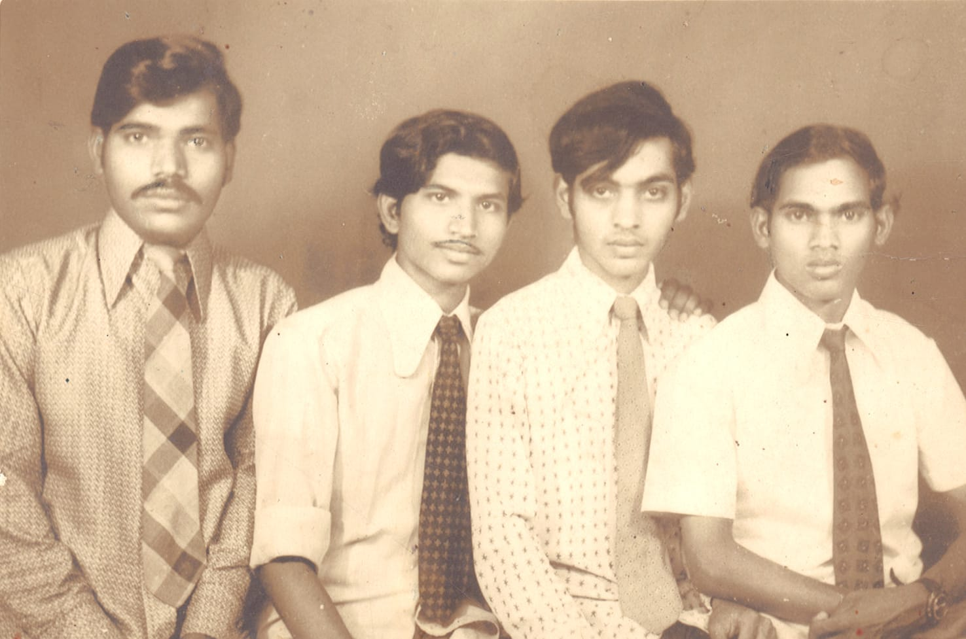  Standing with my friends (third from left )
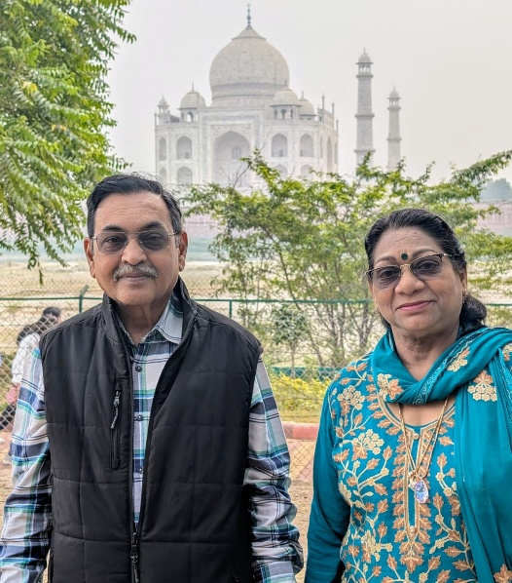  A Trip to Taj Mahal | 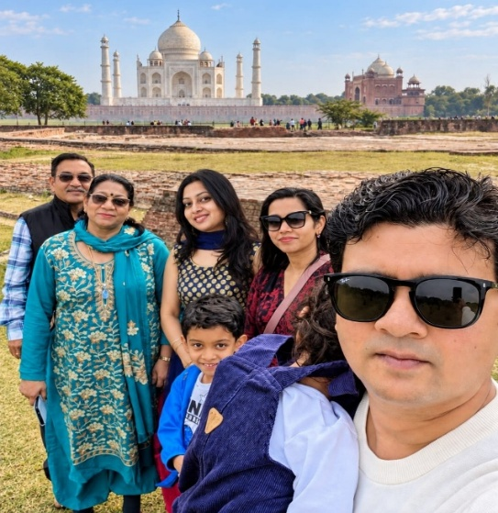  Left To Right: Myself, my wife, younger daughter, elder daughter, son-in-law and kids during our visit to Taj Mahal to celebrate grandson's 7th Birthday

Full Name | P .V. Shajan
Nick Name | Verghese
Branch | Mechanical
Email | pvshajan1@gmail.com
Phone | 9907183606
Current Location | Bhilai India
Educational Qualification | Engineering Graduation
Professional | I Join at SAIL .It's unit of Bhilai Steel Plant  in 1980 as Jr Engineer. My Initial postings were at Nandini Lime stone mines. I retired from Mines in 2013 .
Family | I have small family wife one son & one daughter Both are Engineering Graduate  & MBA. Daughter married & in service.
Memory from College Days | --

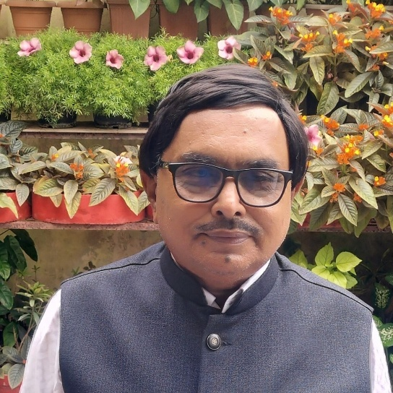  P .V. Shajan: Now | 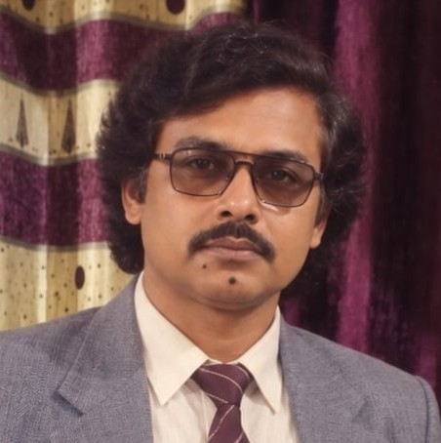  P .V. Shajan: Then
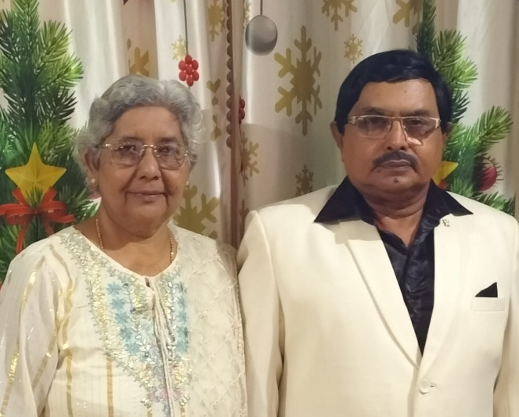  With family members | 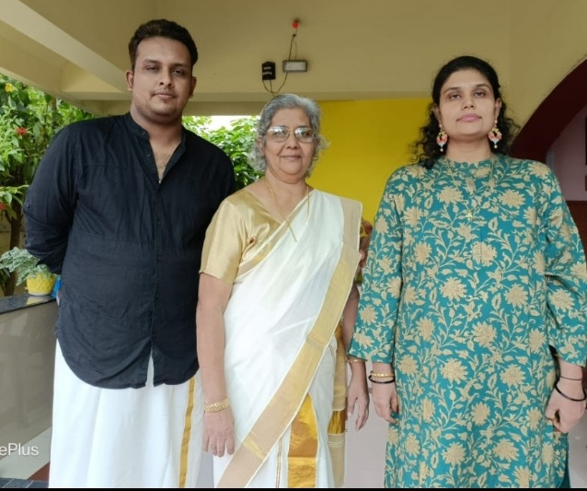  With family members

Full Name | Arvind M. Marathey
Nick Name | Arvind
Branch | CHEMICAL
Email | arvind.m.marathey@gmail.com
Phone | 9329350777
Current Location | HIG, 25, HUDCO, BHILAI, CG, 490009.INDIA,
Educational Qualification | B.Tech.
Professional | I began my professional career with Bhilai Steel Plant, where I gained valuable hands-on experience and developed a strong understanding of industrial operations, plant processes, safety practices, and workplace management. Subsequently, I worked with BRP at present as Director at GIOXIS Works OPC Pvt. Ltd., Bhilai, Chhattisgarh.
Family | I am blessed with a well-educated and professionally accomplished family. My son, Vaibhav A. Marathey, holds a B.Tech. in Electronics & Telecommunication Engineering (E&TC) and is currently working as a Senior Manager in the Transmission Circuit division in Pune. His wife, Shweta Marathey(Shweta Wagh) is a B.Tech. graduate in Information Technology and a Gold Medalist from NIT Raipur. She is also an alumanai of NIT Raipur and has built a successful career as a Senior Software Engineer at Broadcom, Pune.  My daughter, Dr. Priyanka Marathey, holds a B.Tech. in Electronics & Telecommunication Engineering (E&TC), an M.Tech. in Energy Management Systems, with a specialization and research focus on Solar Energy, and a Ph.D. in Electronics Engineering and Materials Science. She is currently working as a Senior Project Manager at College of Engineering Pune (COEP) Technological University, where she is involved in academic, technical, and research-oriented projects. We take great pride in the educational achievements and professional accomplishments of our children and their commitment to engineering, technology, research, and innovation.
Memory from College Days | I fondly remember our wonderful college days when we used to gather in our room with our dear friend Bhattacharya and many other friends. We would all come together, especially in Umesh Chitalangia’s room, where we enjoyed memorable music sessions and informal mehfils. Those evenings were filled with music, laughter, friendship, and countless joyful moments. We had very little in terms of material things, but we had the priceless company of good friends and the freedom to enjoy every moment together. Looking back, those simple and beautiful days remain some of the most cherished memories of my life. The friendships we made and the moments we shared during those college days will always hold a special place in our hearts.

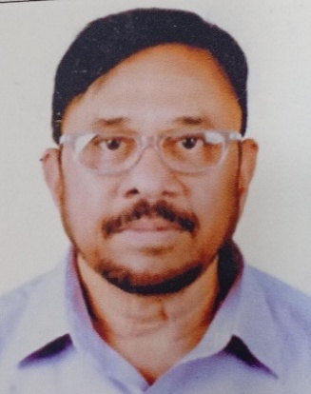  Arvind M. Marathey: Now | 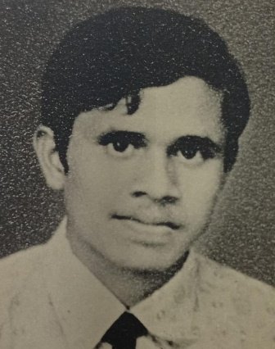  Arvind M. Marathey: Then
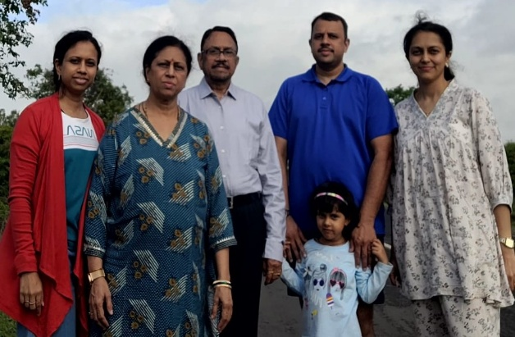  A family photograph with my son, wife and daughter | 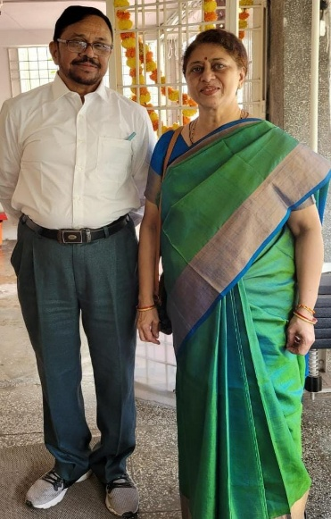  Wife and I

Full Name | Ajay Sadani
Nick Name | Ajju
Branch | Mechanical
Email | ajaysadani@gmail.com
Phone | 9820084931
Current Location | Mumbai, India
Educational Qualification | Did my Schooling from Vikas Vidyalaya Ranchi) in 1971 & Graduated from Raipur Engineering College (Mechanical) in 1976 Batch
Professional | Post Graduation I worked for 4 years & later started my Business in Manufacturing of Commercial Refrigeration Equipments under the Brand name 'HONEYDEW' in Mumbai
Family | My Wife, Mala and I have two Son. Our Elder son, Rahul is married to Preeti and Our Younger son, Rohit is married to Raksha. Both our Son are actively involved in our Family Business. We are also Blessed with a loverly Granddaughter and Grandson, Kiara and Aarav.
Memory from College Days | I was an active Badminton Player during my College days and had the opportunity to Win several matches for my College. I also fondly remember the wonderful group of college friends I had. We often met in the city and spent Quality time together, especially at the Indian Coffee House. Those carefree days, the friendship we shared and many memorable conversations over coffee remain some of my happiest college memory.

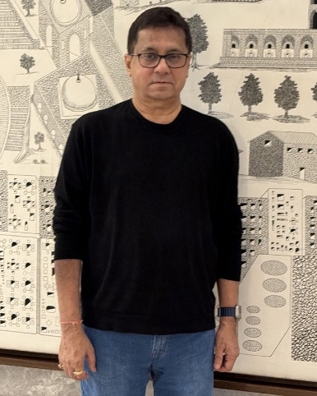  Ajay Sadani: Now | 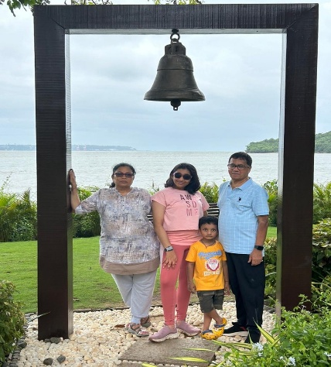  A holiday photo with Mala, Kiara and Aarav
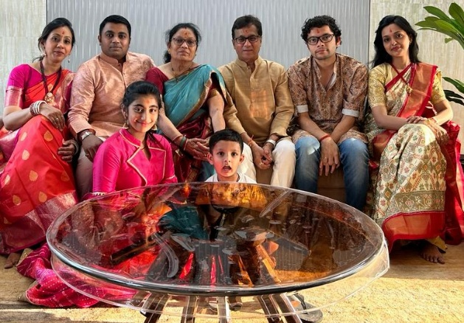  Celebrating Diwali with my whole family together | 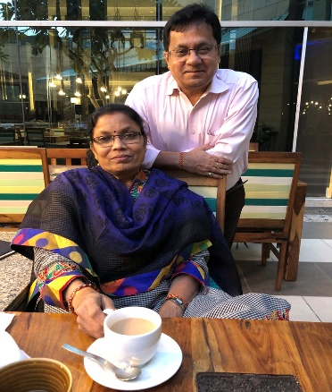  With my better half Mala

Full Name | Sanjay N Joshi
Nick Name | --
Branch | Chemical Engg
Email | snjoshi2512@gmail.com
Phone | 9850983209
Current Location | Pune , India
Educational Qualification | M Tech Chemical Engg
Professional | Almost 30 years in technical consultancy company providing engineering,construction and commissioning services for Chemical, Petrochemical, Fertilizer and allied industries (Mumbai and Pune )  Worked in Italy ( Milano ) for almost 2 years ( 1989 - 1991 ) with a small engineering firm.  Post retirement, settled in Pune.
Family | We have a son and a daughter, both well settled . My wife worked for almost 10 years post marriage and then continues to be housewife.  Daughter too worked for 10 years in IT field in Pune and USA and now takes care of her family with 2 kids as housewife and home maker.  My son has done his MS in Mechanical Engineering from US and has recently moved back to India after working there for 12-14 years.  My daughter-in-law also completed MS in IT from US and now she is a proud mom of a 2 year old daughter.
Memory from College Days | --

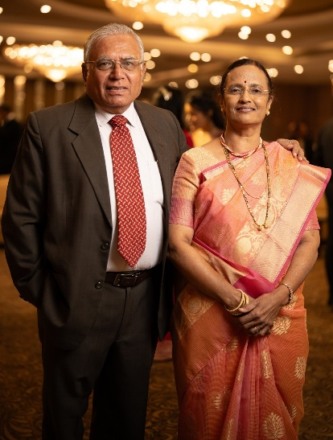  Sanjay N Joshi: Now | 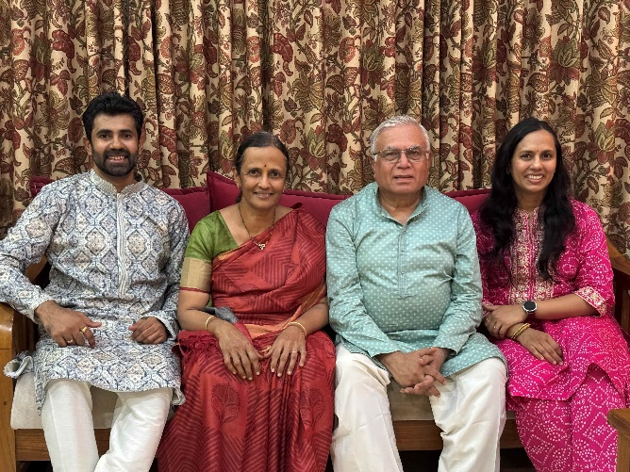  With my wife Shivani and children Manasi & Rohan
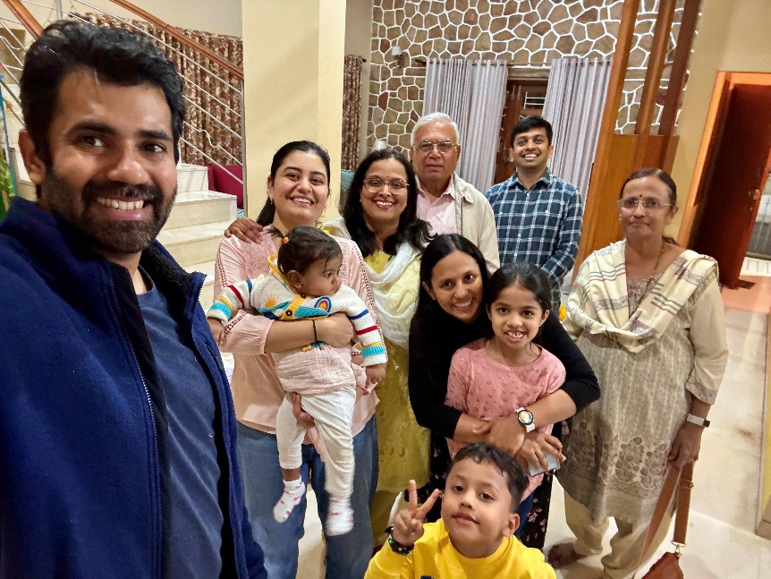
With my family and grandchildren

Full Name | Mukan Chand Kanuga
Nick Name | Kanuga
Branch | Civil Engineering
Email | kanugamc@gmail.com
Phone | 9460814911
Current Location | Durg, Chhattisgarh, India
Educational Qualification | B.E. (Civil), 1971 - 1976
Professional | - Sep'76 - May'77 - Junior Engineer, Irrigation Dept, Rajasthan.  - May'77 - Dec'82 - Millitary Engineer Services, Govt of India.  - Dec'82 - Jan'15 - PWD, Rajasthan. Served as SQC, PMGSY Rajasthan. Retired as S.E. PWD.  - Sep'15 - Jan'25 - Worked as NQM, NRIDA, Govt of India & SSQM, MMGSY Maharashtra.
Family | Residential Address - MIG 730, Padmanabhpur, Durg, CG with family.  - Elder son working at Deloitte, Mumbai.  - Son in law working at Cisco, Bengaluru.  - Daughter working at Oracle, Bengaluru.  - Younger son working at Amazon, Bengaluru.
Memory from College Days | - After merit position in 2nd year, met with Principal Sarvathe sir - First to change branch from Chemical to Civil; then to change from Civil to Electrical in the presence of HOD, Electrical, Prof Igbote. Principal sir asked to come back after 1 week for the change. Did not meet again & continued with Civil Engineering.  - During Emergency period, 1975, became the Prefect of Hostel-B as directed by the Warden Prof B. M. Thakare.  - During my stay in Hostel-A in 3rd & 4th year, with my friends A. K. Srivastava & others, kept a bunch of bicycle master keys, and used to go for second show by picking 1/2 bicycles in the hostel. Once while returning after midnight, caught red-handed by the actual owner, a day scholar senior from Chemical, who was waiting at the hostel main gate.

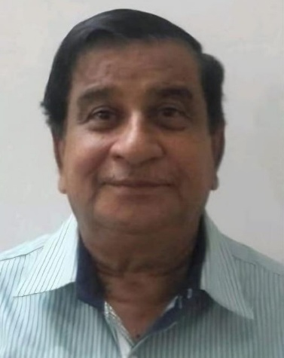  Mukan Chand Kanuga: Now | 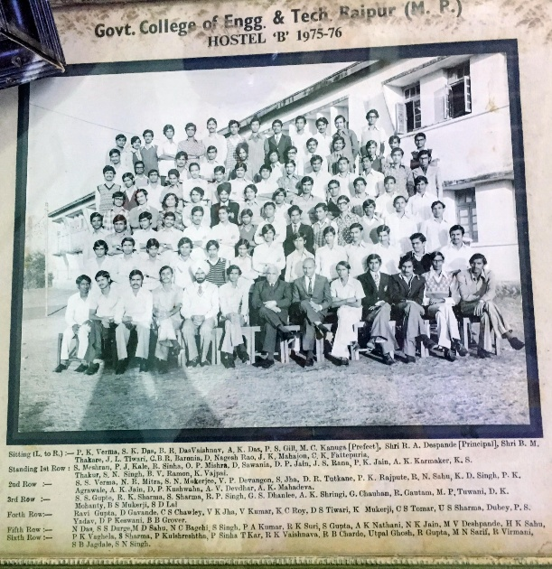  Group Photo of Hostel 'B' (1975-76)
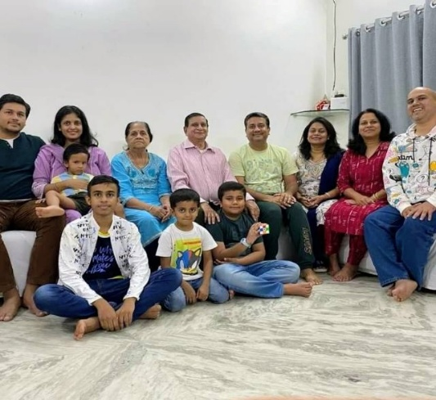  A family photo with wife, children and grandchildren | 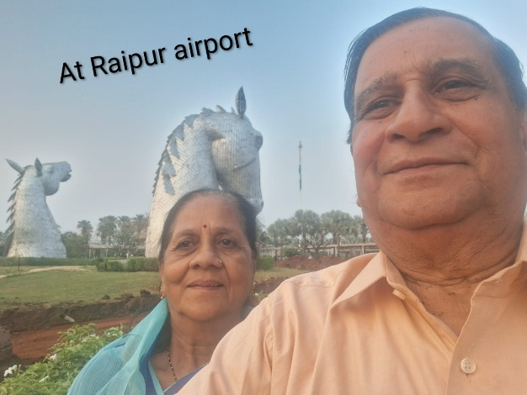  Flying high with better half

Full Name | Jawahar Gandhok
Nick Name | --
Branch | Civil Engineering
Email | jawahar.gandhok@gmail.com
Phone | 9229221622
Current Location | Bhilai, India
Educational Qualification | M Tech (Modern Steel Technology),BE (Civil), Chartered Engineer
Professional | A distinguished Civil Engineer with nearly five decades of rich and diverse experience in government service, large-scale project execution, and successful entrepreneurship.  Graduated with a Bachelor of Engineering (Civil) in 1976, commenced professional career with the Department of Irrigation, Government of Madhya Pradesh, gaining foundational experience in large-scale infrastructure and water resource management.  Subsequently, served as a Junior Engineer with the Central Public Works Department (CPWD) from October 1977 to April 1978, involved in central government construction projects adhering to stringent quality and compliance standards. Further served as a Grade-I Civil Engineer with the Military Engineer Services (MES) from April 1978 to October 1978, contributing to critical defence infrastructure projects.  From 1978 to 1984, held the pivotal position of Project Engineer at the prestigious National Dairy Development Board (NDDB). During this six-year tenure, successfully conceptualized and executed several landmark dairy projects across India, including Mehsana, Ahmedabad, Indore, Ujjain, and Gwalior, demonstrating exceptional project management and leadership capabilities.  In 1985, driven by an entrepreneurial vision, transitioned from public service to private enterprise and established a plastic manufacturing unit, which was successfully operated and scaled.  Building on this success, in 2002, strategically diversified and expanded into high-potential sectors including specialty chemicals, refractory materials, and steel fabrication. Today, under the banner of SATGURU REFRACTORIES, the enterprise leverages 40 years of entrepreneurial expertise and deep-rooted industry relationships, ensuring strong business continuity, technical competence, and financial prudence.
Family | I am blessed with a close-knit, educated and supportive family, which is my biggest strength in both life and business.  My wife, Mrs. Nutan Gandhok, is not just my life partner but also my business partner. She co-owns Satguru Refractories and has been the pillar of our 40-year entrepreneurial journey.  Our elder son, Vinay, is a BE in Computer Science and MBA in Marketing. He is well-settled in Singapore along with his wife Vaishali, and brings us global exposure and modern business insights.  Our younger son, Varun, is a BE in IT and is the driving force behind our current business operations. He efficiently manages day-to-day activities, technology and expansion, ensuring business continuity.  His wife, my younger daughter-in-law Anjali, is highly qualified with MCom and MCA degrees and is passionately pursuing a career in teaching.  Together, we are a family of professionals with strong values, combining experience, technology and education to take our family business forward.
Memory from College Days | --

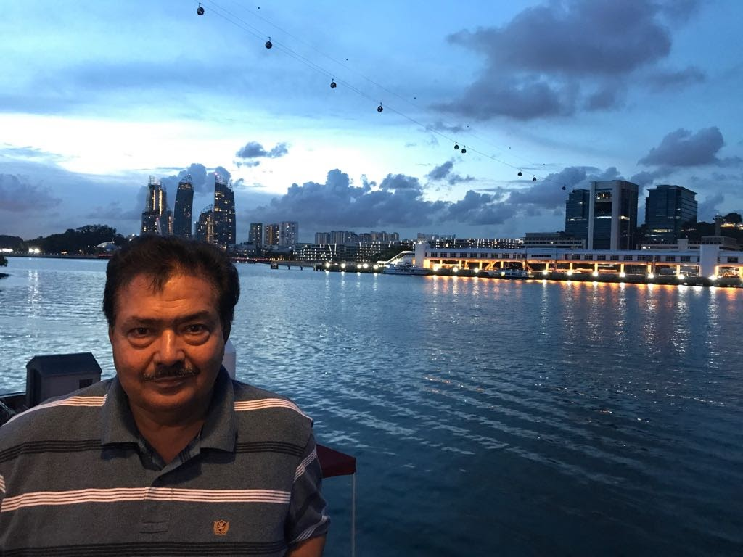  Jawahar Gandhok: Now | 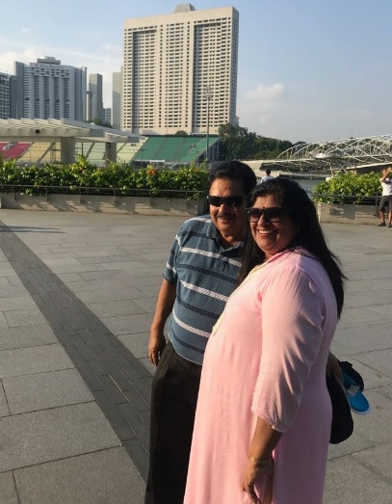  With my wife
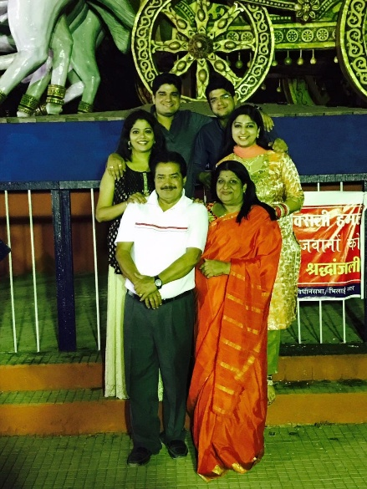
My whole family

Full Name | Yashwant K. Gaikwad
Nick Name | Yashwant
Branch | Metallurgy
Email | ykgaikwad@gmail.com
Phone | 9850616369
Current Location | Pune
Educational Qualification | BE, Diploma in Computer Science( Shivaji University)
Professional | Started with Int Tractor Co of India (M&M)Mumbai, Later SAIL BOKARO, Later resigned and started SSI in Solapur (Proprietorship), Later ran NIIT franchisee in Solapur (Pvt Ltd Com.) Afterwards started a Pvt Ltd venture in MIDC Solapur.
Family | Wife: Mrs Neelima Y Gaikwad Retired HOD Govt Polytech Maharashtra State. Son : One, BTech,from Pune, MS (Columbia University) MBA UC Berkeley.
Memory from College Days | Fifty years on, Raipur batch feels like a prototype that somehow never crashed. Recalling those old days in hindsight seems like taking a trip down memory lane. 50 years back we arrived in college as a nervous boys from small towns, left as hopeful graduates and discovered that real syllabus is only 1% Cabon and 99% chaos. I may not remember all faces now but our shared moments of camaraderie, hanging out, and safety net it provided still fills me with glowing warmth and evokes sweet memories. Not having enough money to pay for movie cycle stand, cutting tea at Netaji Hotel, hopping from one friend’s place to another, doing homework together have all made them stuff of folklore. Our dedicated teachers like Dr Kamth, Professor Telang ,Professor Pillai ,Professor Ghatge, thank you for laying the foundation, shaping us what we are today. Thank you, all our batch mates, for making those ordinary days extraordinary and unforgettable.

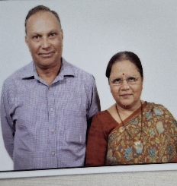  Yashwant K. Gaikwad: Now | 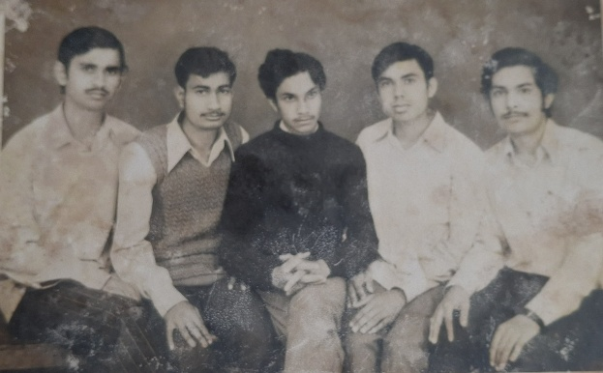  From Left: Late D C Chavda, Anant Rajimwale, YK Gaikwad, Sanjay N Joshi, Yogesh Degan
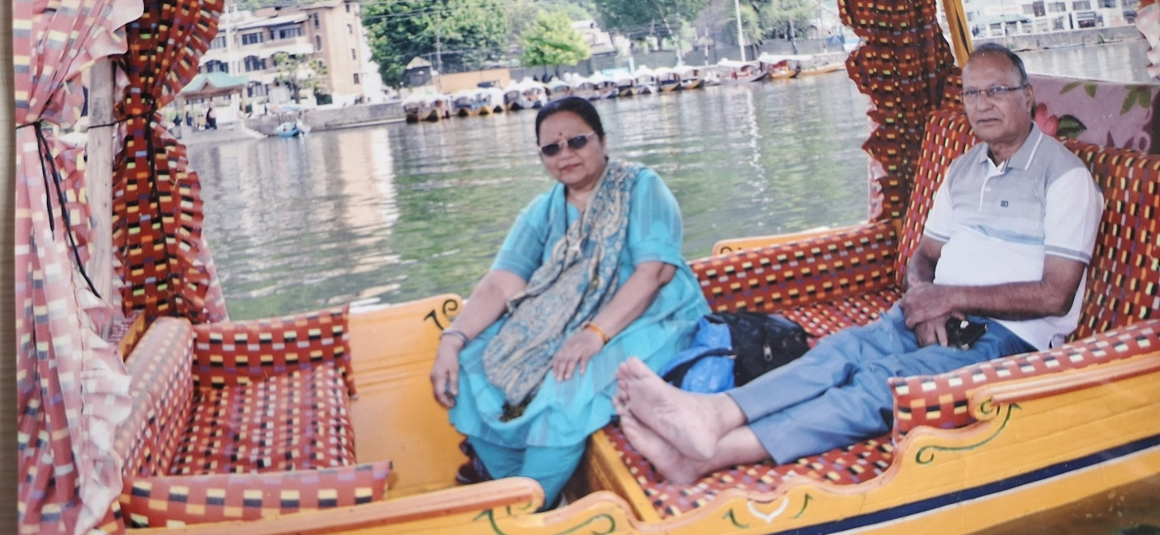
Kashmir, Dal Lake with Uday Vadavi

Full Name | GVR Raja
Nick Name | Raja
Branch | Metallurgy
Email | gvrraja537@gmail.com
Phone | ------
Current Location | Bhilai
Educational Qualification | B.E.
Professional | After completion of degree, I joined immediately as a Graduate Apprentice at BSP, Bhilai in 1976, then subsequently joined as Graduate Engineer Trainee at SAIL, BSP in March' 1977. Worked at BSP for 30 years till 2006. On transfer, I continued service at RSP, Rourkela worked there for nearly 8 years. Subsequently, after retirement, I returned to Bhilai in 2014, and settled here, permanently.
Family | We have 2 sons and one daughter. All are married. We have 3 grandsons, one each from our 3 children. Elder son settled in Germany, younger son at Pune and daughter works at Raipur/Bhilai.
Memory from College Days | During our final year at college, Late Shri K K Telang sir, who was then our new HoD, had been encouraging and motivating the entire group of Metallurgy wing students, both 4th and 5th year combined together. Under his guidance along with our local classmate YK Degan's untiring efforts, we had great time at the college, as well as during our industrial tour to Mumbai, Hyderabad and other places, where we visited various metallurgical plants, assessing our own job prospects. It would have otherwise been a rare possibility, as there were only 3 students in our branch, during final year.

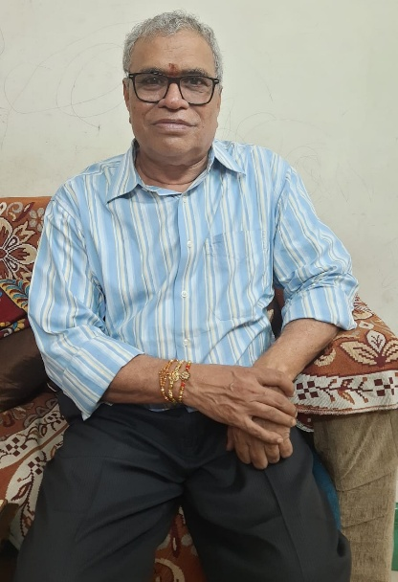  GVR Raja: Now | 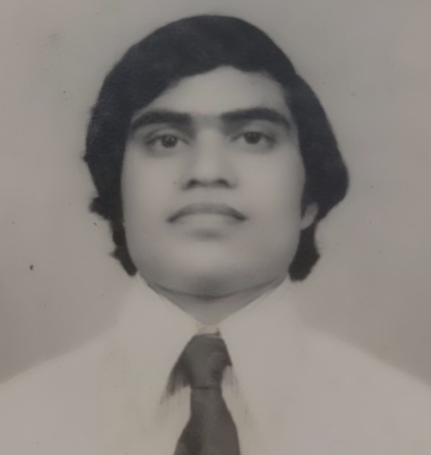  GVR Raja: Then
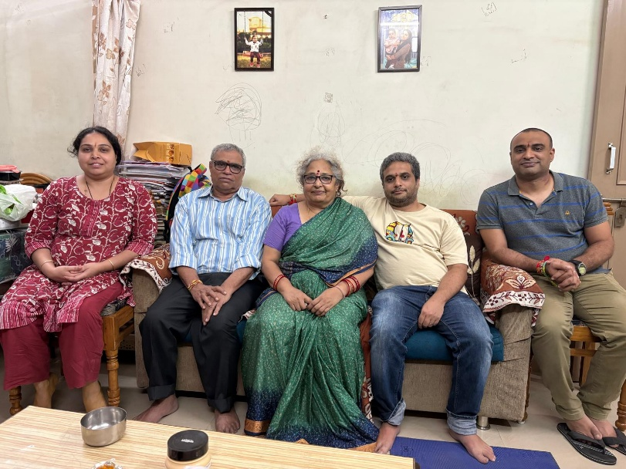
GVR Raja and Family

Full Name | Anant Prabhakar Rajimwale
Nick Name | Anant
Branch | Metallurgical engg
Email | anant.rajimwale@gmail.com
Phone | 9893411846
Current Location | Raipur, India
Educational Qualification | B.E from G C E T Raipur. M Tech from IIT Bombay. Both degrees in Metallurgical Engg
Professional | I worked as Associate Prof at N I T Raipur. I served the institute in several capacities including:  1. Head of the dept , Met Engg.  2. Dean, Students Welfare  3. Dean, Faculty Welfare
Family | My wife retired as a Lecturer and Vice Principal at Gujrati School, Raipur. We have 2 sons. One in U S A. and one in Bangalore. Both of them are working as Software Engineers in multinational corporations.
Memory from College Days | I consider myself very fortunate to have worked as Professor and Dean at the same institute (then GCET Raipur, now NIT Raipur) where I graduated from with a B.E. degree. Further, during my tenure as Professor at NIT Raipur, I was also the hostel warden for the same hostel that I had visited as a student to study with my fellow batch mates. After my retirement, I feel proud to have served this prestigious institute that has been a major part of my life and achievement.

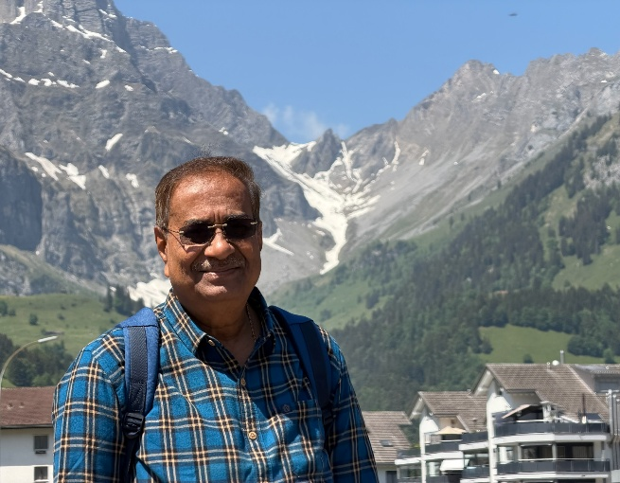  Anant Prabhakar Rajimwale: Now | 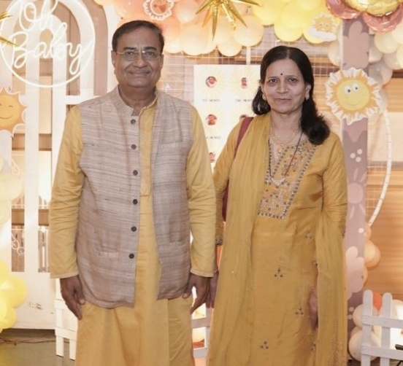  Recent Photograph with my wife, Megha
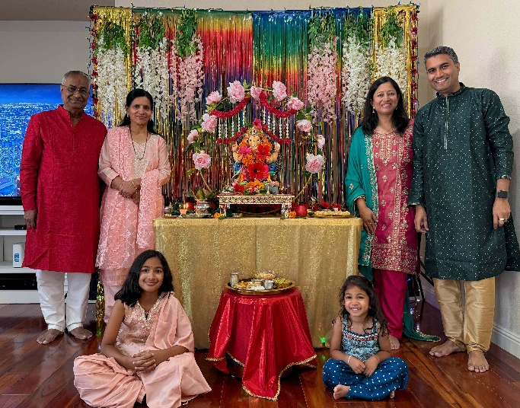  This is a photograph from recent Ganesh Utsav that we celebrated together in San Jose, California (USA) at my elder son Abhishek's home. Like every year, my grandkids were excited for Ganesh ji to come home | 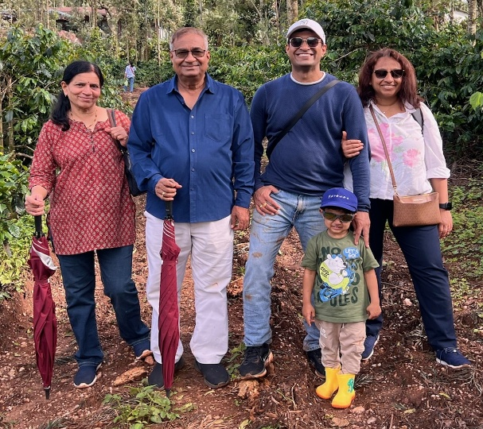  Recent photo with my younger son Sameer and family in Bangalore

Full Name | Durga Prasad Sharma
Nick Name | --
Branch | Civil
Email | sharmmadp09@gmail.com
Phone | 9302935000
Current Location | 31/1372, Durga Niwas, Behind Dr. Kalda Nursing Home, Katora Talab, Raipur C.G.
Educational Qualification | B.E. (CIVIL), LLB, M.A. POLITICAL SCIENCE, MBA, MIE
Professional | Retired as Chief Engineer Water Resource Department, Govt. of Chhattisgarh
Family | Spouse: Shashilata Sharma.  Daughter 1- Bhavna: Working as Dean Anjaneya University & Son-in-law: Asim Kumar, Working as assistant Director, Bilasa Blood Bank.  Daughter 2- Bharati: Working as teacher & Son-in-law: Satyadeep Pandey, Working as Manager Adani Power, Korba, C,G.
Memory from College Days | --

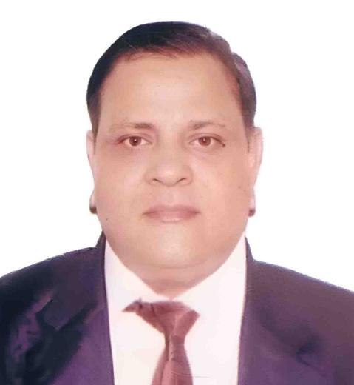
Durga Prasad Sharma: Now

Full Name | Rithik Choudhury
Nick Name | --
Branch | Chemical Engineering
Email | rithik1955@gmail.com
Phone | 7587124705
Current Location | Bhilai
Educational Qualification | I got admission in the year 1971 in engineering college. I got degree in chemical engineering in 1977. I passed PG diploma in business management in 1993 from Ravishankar University.
Professional | After passing B. E. in chemical engineering, I got involved in various activities for job initiative. Then I joined Resinate chemical plant in 1979 at industrial state in Bhilai. In 1983 I joined Bhilai Refractories Plant in Bhilai. Now it is Sail Refractories Unit , a Sail Unit. I retired from there in 2015 February.
Family | I have a small family, me , my wife my daughter. My wife is a housewife. My daughter after passing M A in history from Delhi, and she joined other courses in Delhi.
Memory from College Days | I could remember many things . Maniram canteen near the Ayurvedic College . We used to go there every evening after college and end for evening snacks . Every Saturday we used to go to the railway station to go to Bhilai by the pave of the railway line side that was a very amazing experience . Often, we rent bicycles near the bicycle shop to go to the city. One day when I was returning to the hostel, I slipped on the road and fell down. I was lucky at that time road was empty. I could not forget the incident till today.

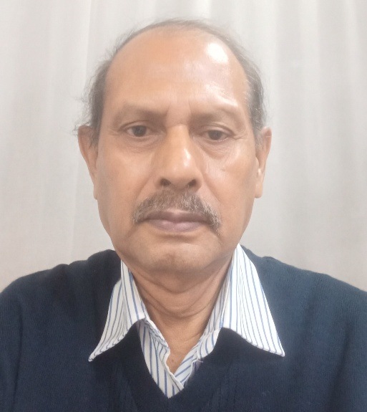  Rithik Choudhury: Now | 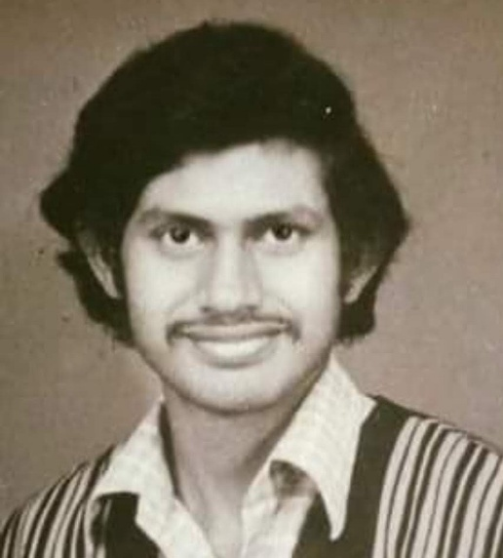  Rithik Choudhury: Then
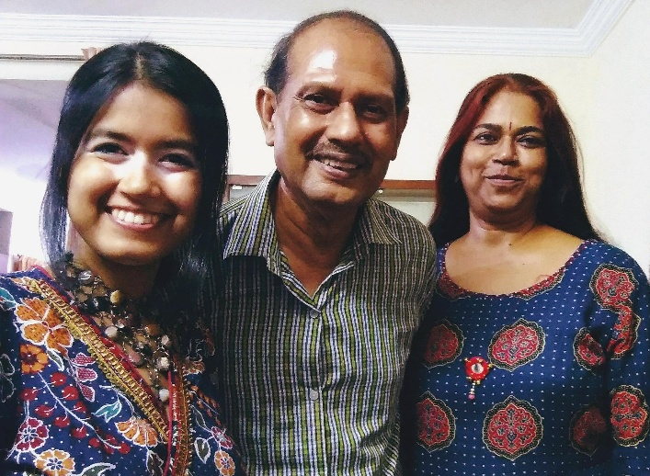  This photograph was taken at the time of Durga Puja after retirement in 2018 | 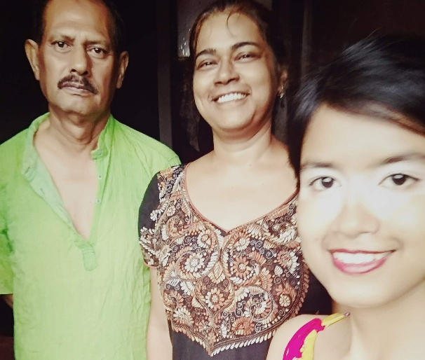  I captured this photograph at the time of Holi in 2019

Full Name | Rajiv Charde
Nick Name | Raju
Branch | Civil
Email | rbcharde1956@gmail.com
Phone | 9822696736
Current Location | Nagpur India
Educational Qualification | BE Civil and Post Graduate Diploma in Construction Management from IIM Ahmedabad. Founder member of Indian Concrete Institution.
Professional | First two years with Gannon Dunkerley at IFFCO plant construction site@Phulpur. 8 years with Tata Consulting Engineers Mumbai. 8 years with BG Shirke construction company. From year 2000 till retirement in 2016 with SMS Infrastructure at various sites. Retired from there as Vice President. Varied work experience of tunnels, highway, railways dams, pre fab housing etc. Now I am working as consultant.
Family | I have two daughters both working abroad in USA and Ireland. My wife Savita was a mechanical engineer who was HOD at Govt Engineering college Amravati. Sadly lost her in a car accident
Memory from College Days | When I was thrashed by seniors ( won't take the names ) for silly mistake. Alas when we became senior it was Emergency period.

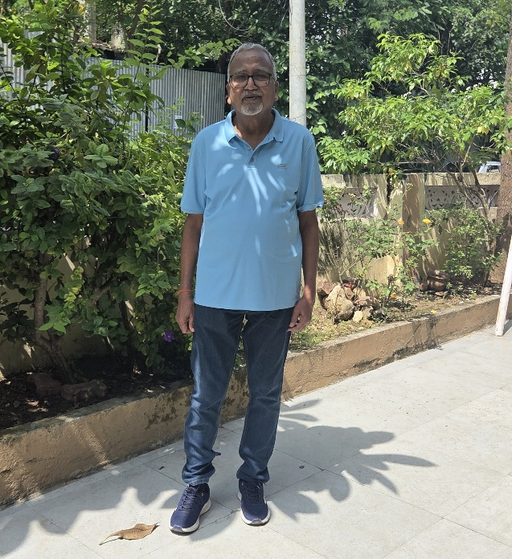  Rajiv Charde: Now | 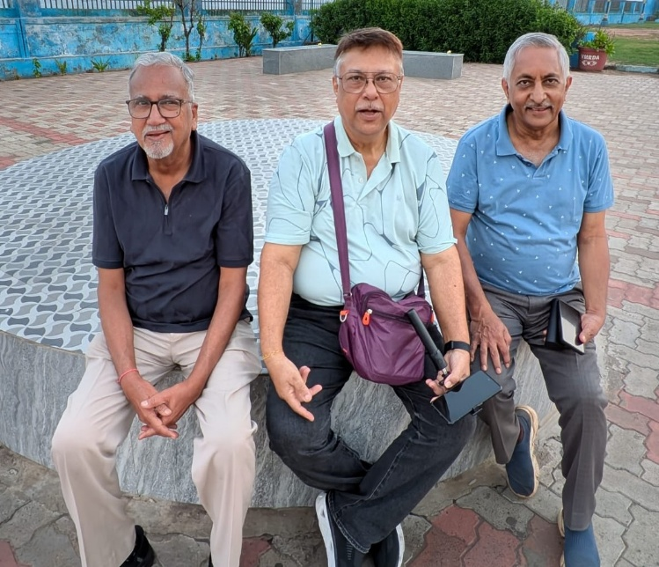  With college batchmates Utpal Ghosh and Uday Vadavi

Full Name | Nakib Ullah Khan
Nick Name | Nakib
Branch | Mechanical
Email | anfin76077@gmail.com
Phone | 9893376077
Current Location | Raipur, Iindia
Educational Qualification | B.E.(Mech). CAIIB From Indian Institute of Banking & Finance
Professional | Immediately after passing I was struggling for job. I joined Raipur Wire & Steels as Trainee Engineer but after completing training nature of job was tuff. I had two work for 12 hours and even on Sunday there was no holiday. So after one and half year I resigned and continued to apply for Govt. jobs.  At that time there was common presumption that Govt. jobs are safer. So I continued to appear for written tests and interview for Govt. undertaking companies, however in the meantime for short duration
Family | Two sons are both software engineers working in USA. Elder son has one daughter 4 years old.
Memory from College Days | When I was in first year, the engineering drawing classes were for 4 hours each. Dr. Saikhedkar Sir was our teacher. We enjoyed the moment when he used to say, ‘Wind Up Please’.

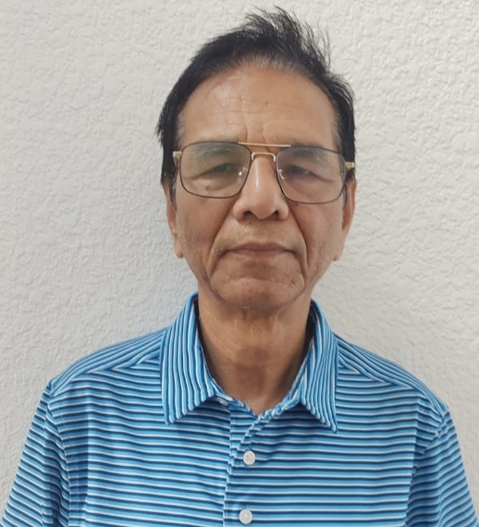  Nakib Khan Now | 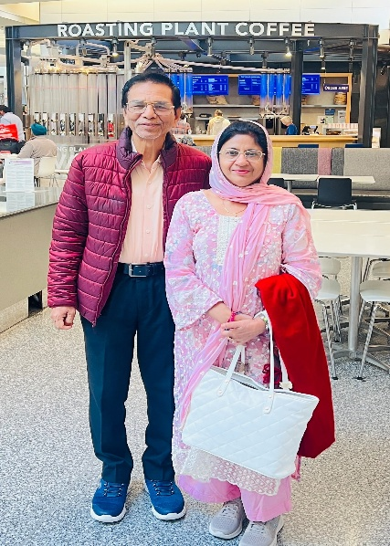  Nakib Khan with spouse
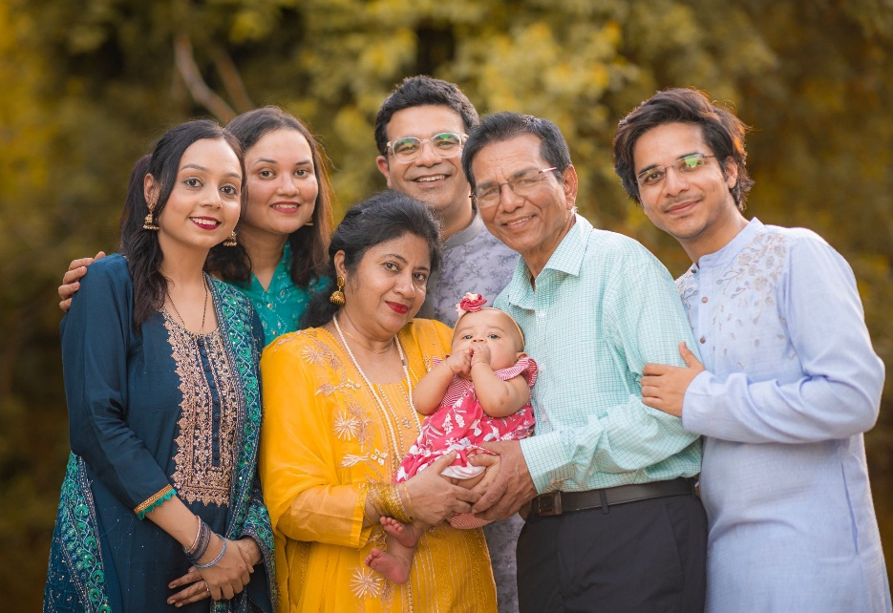
Nakib Khan with Family

Full Name | Jaiman Minj
Nick Name | --
Branch | Mechanical
Email | jaimanminj@gmail.com
Phone | 6264457327
Current Location | Bhopal, M.P., India
Educational Qualification | BE(MECH), MBA
Professional | Joined BHEL as Engineer trainee in JAN 1977  then promoted from  Engineer trainee _ to _ Engineer  To _ Senior Engineer  To_ Dy Manager  To_ Manager  To_ Sr Manager  To_ DGM  To_ Sr DGM  To_ AGM  And Finally to GM in 2010, All posting till 2012 was in BHEL Bhopal, then in year 2012 transferred to "Power Sector" western region Nagpur  And retired as GM in JUNE 2014.
Family | 1. Wife  Dr. (Mrs.) Basanti Minj  MBBS, MD(anesthesiologist)  Joined Indian Railways through UPSC and retired as CMS (Chief Medical Superintendent)  2. Vikrant Minj (Elder son)  B.Tech. (Electrical), M.Tech. (Energy)  Working in BHEL Bhopal as Sr. Manager  3. Dr. Aarti Minj w/o Vikrant Minj  MBBS, MS(ophthalmologist), FVRS(Retina surgeon)  4. Janessa Vivian Minj(3.5 yrs old) d/o Vikrant & Aarti minj  5. Jerald Vaibhav Minj (Younger son)  BE(CSE), MTech(IS)  Working as Assistant Manager at MPGB  6. Annie Ankita Minj w/o Jerald Vaibhav Minj  MBBS, MS(ophthalmologist), Medical Glaucoma specialist
Memory from College Days | In early days of 2nd year, I was days-scholar from Durg to Raipur. Once I missed the train for Raipur and went Raipur by bus. That day it was lucky for me, as that very day, there was a Magisterial checking in the train. All were caught by Magistrate because mostly we were travelling without tickets and I was the lucky one to escape.

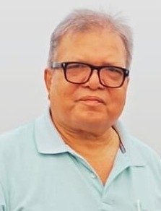  Jaiman Minj Now | 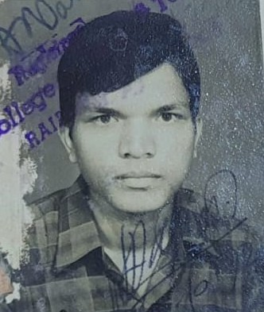  Jaiman Minj Then  (Taken from College ID)

Full Name | Sheel Kant Pathak
Nick Name | --
Branch | Civil Engineering
Email | skpathak54@gmail.com
Phone | 8085528240
Current Location | Raipur Chhattisgarh India
Educational Qualification | B.E.
Professional | 1. After Graduation I served briefly in Water Resources Departments of Madhya Pradesh, then I served in Special Area Development Authority Durg. Then afterwards I joined Indian Oil Corporation Ltd. as Project Engineer in Guwahati.  2. From 1977- 1981 I served in Bhilai Steel plant- SAIL as Construction Engineer (4 MT expansion).  3. From 1981 to 2016 I served Water Resources Department of Chhattisgarh and retired as Chief Engineer. During this period I have designed, initiated and constructed various World Bank Aided Medium Irrigation projects like Chhirpani, Shyam Ghunghutta, Chando Diversion and Sutiyapat projects and many Major Irrigation Projects like Ravishankar Dam, Mahanadi Canal system and Hasdeo Bango Minimata Canal System, which are the agricultural life line of the State.  4. As a passionate person of Literature, History, Social and culture, I engaged myself as a Hindi Poet and Writer with 02 Published books of poetry, And many published Articles and Poems in renowned magazines and Newspapers like Navbharat, Daink Bhaskar, Nayi Duniya Haribhoomi, Dainik Hindustan, Kadambani, Lokakshar, Vagarth, Vyangya Vividha, Nayi Gudgudi, Gagananchal, Indraprasth Bharati, Bhasha, Sakshatkar, Samkalin Bhartiya Sahitya, Akshara and many more.  5. Principal Editor of "Chhattisgarh Parikrama".  6. Well Known as Senior Poet, Writer of Chhattisgarh.
Family | Spouse - Dr. Archana Pathak, PhD (Classical Music), M.Sc.(Botany), LLB., Ayurved Ratna. Certification in movie making, Diploma in Classical Instruments (Sitar).  worked as Editor of quarterly Hindi magazine "Chhattisgarh Parikrama". Founder of Cultural organization "Sakar Srijan". Worked as Anchor in Doordarshan and Akashwani Raipur for different cultural programs. She is a Poetess and Writer of many books published from Raj Bhasha Aayog and Sanskriti Vibhag of Chhattisgarh.  Anniversary- 18 June.  Children - 1. Richa, Post graduate in Management from NMIMS Mumbai. B.E.(CSE) from Pt. Ravishankar Shukla University. worked as Software professional in the Clearing Corporation of India ltd Mumbai. District Skill Development Officer, Raipur. Currently working as Court Manager, Administrative wing of The High Court of Chhattisgarh.  2. Neha, Post graduate in Management from IIM Raipur, BE(CSE) from NIT Raipur. worked as Software professional in HSBC and First Data Pune, currently working as Sr. Delivery Manager and Product Owner at TCS Bengaluru.  3 Prachi, B.E.(CSE) from CSVTU Bhilai, pursuing post graduation in Mathematics.  working in School Education Department of Chhattisgarh.  Grand Children - 1. Shaurya - a young dynamic girl with lots of dreams in her eyes.  2. Vedant - A Tech Kid with expertise in his hands.  3. Shrtik - Cute boy with bright smile.
Memory from College Days | In fourth/final year, I can't exactly remember the timeline but it was a turning point as I put on makeup for first and last time in my life for a group play of "Guru Ghantal". As I had never thought of Acting before even though I am a good actor in my family life. Me and My friends Narendra, Yogesh, RamaShankar and others under the initiation and motivation of Res. Prof Rajesh Pathak sir to act in that play which was praised and applauded in our Annual College Function and ultimately won a Best Play Award in the youth festival of Ravishankar University. This Award Enhanced my overall personality and made me self-Assured and confident that I can do the things which comes in my life path.

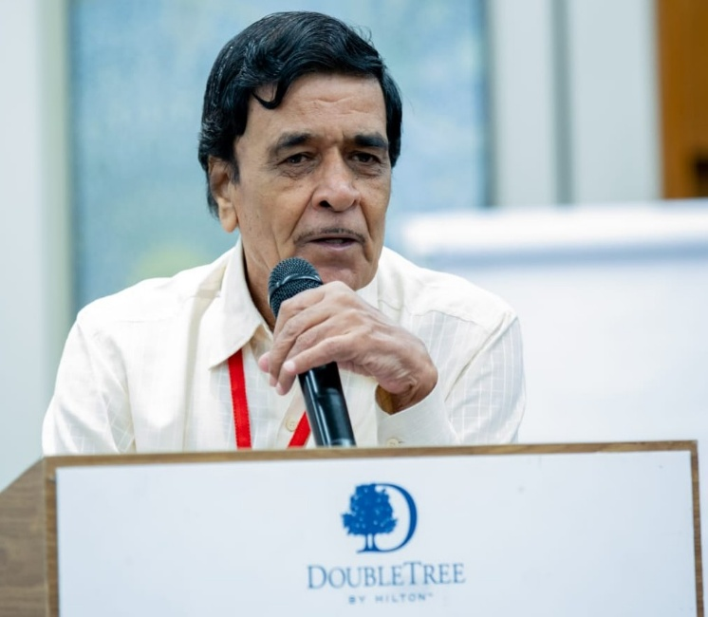  Sheel Kant Pathak: Now | 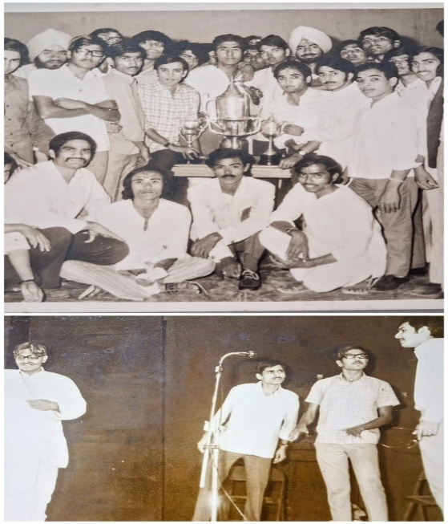  Scenes from the play "Guru Ghantal", performing artists (from left to right - Narendra Thakkar, Ramashankar Gupta, Sheel Kant Pathak, Yogesh Degan. Also group photo of the award winning team
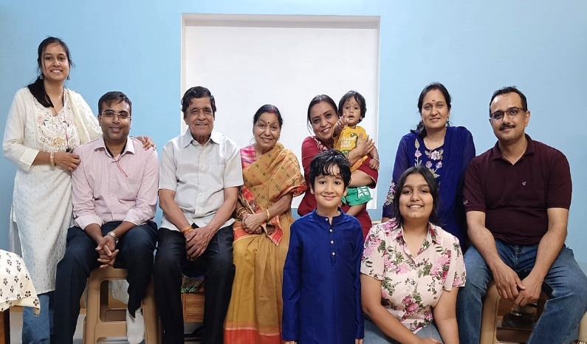  Family group photos with all three daughters, Son-in-laws and Grand Children | 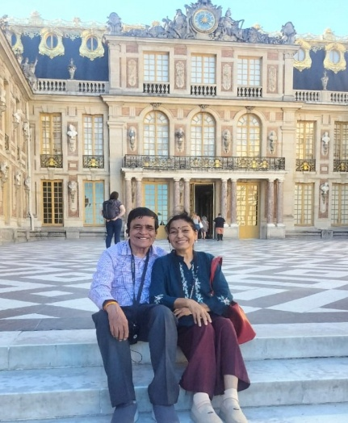  With my Better half in front of Palace of Versailles, France

Full Name | Jayant Diwakar Muley
Nick Name | Muley
Branch | Civil
Email | jdmuley55@gmail.com
Phone | 8600037799
Current Location | Nagpur, Iindia
Educational Qualification | Batchlor of Engineering (Civil), 1976
Professional | I began my career in July 1976 with Gannon Dunkerley & Co. Ltd. (GDC), a professionally managed company of repute specializing in civil and structural works including water & sewage treatment plants, overhead water tanks and chimneys.  During my 30-year tenure with GDC, I worked as Project In-charge on many prestigious projects across India and abroad. Key projects include the 10 Cold Store Project in Iraq, Second Launch Pad for ISRO at Sriharikota, Chennai International Airport, Akash & Agni Missile Projects at Hyderabad, 2x210 MW Power Plant in Bihar and 3x500 MW NTPC Plant at Korba. I was also involved in construction of numerous cement plants, textile mills, pharmaceutical and automobile plants.  From 1995, I served as General Manager-in-charge of Hyderabad and Mumbai Regional Offices, both operating as independent profit centres.  I took early retirement from GDC in 2006 to start my own venture. The initial assignments were civil works for an 80 MW Power Plant for Hindustan Zinc Ltd. at Chittorgarh, a 400 kV Sub-station at Merta and civil & structural works for Uttam Galva Metallics at Wardha.  We undertake works pan-India and have executed projects in Maharashtra, Andhra Pradesh, Madhya Pradesh, Jharkhand, Karnataka and Gujarat. Since inception, the company has consistently attracted sufficient talent to achieve its targeted turnover and revenue. The company is healthy and maintains adequate resources, with a large team of technical, managerial staff and skilled workers engaged across sites to match the requirements.  The journey has been challenging, adventurous and thoroughly enjoyable. I plan to retire at 75 years of age.
Family | I met my wife Kiran at a family function in Gwalior in June 1982. A science graduate, she is quiet, amiable and very observant. She enjoys knitting and cooking. We married in June 1983.  We have two children.  *Siddharth Muley:* Elder son, Engineer & MBA. After stints with UBS Bank and Gammon Infra, he now manages our construction business. He is married to Komal Kothavale Muley — MBA, Certified Career Analyst and founder of _Better You_ (bestseller book summary platform) and _Career Code_ (career support platform).  *Dr Sonal Muley Pande:* Daughter, Ophthalmologist — MBBS, MS. Married to Dr Nikhil Pande — Oncologist, MD & DM from Tata Memorial Centre, Mumbai. Both are settled in Launceston, Tasmania, Australia.  We are a simple family who loves travelling, good food and trekking in hills and forests. Our favourite place is McLeod Ganj, HP.
Memory from College Days | My five years of engineering in the hostel were the golden years of my life.  It was a world in itself- a small shared room, common bathrooms ever debated mess food & friendships for a lifetime.  My close circle- Pawan, Umesh, Guha, Pinaki & many more- we were like brothers. Long late night discussions with endless chai - there was a funny incident every day.  Hostel taught me much more than engineering. It taught me sharing, adjusting, managing within limited pocket money & standing by friends.  Even after 50 years, when we meet, we become same 20-year olds again.

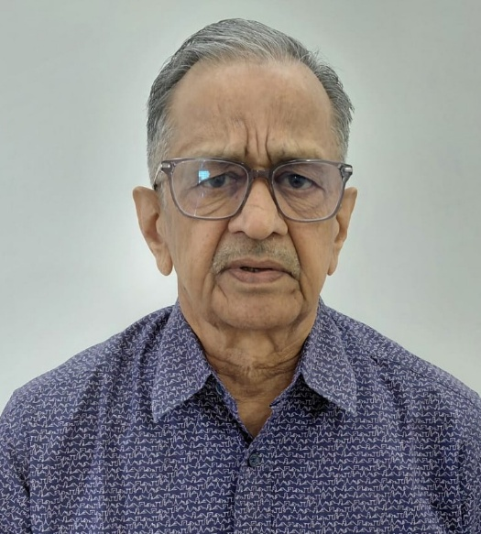  Jayant D. Muley: Now | 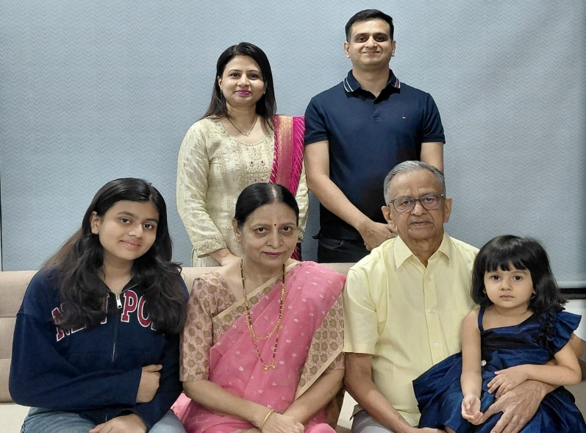  Jayant D. Muley with Family
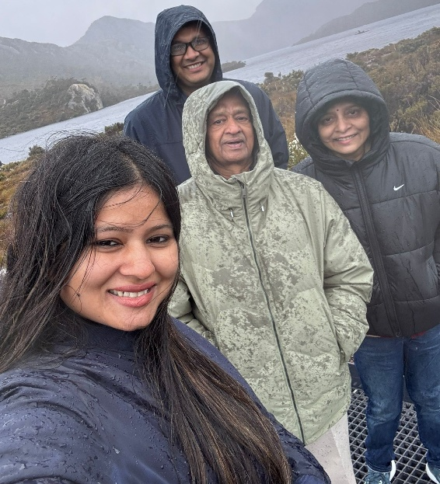  With our daughter Dr Sonal & Son-in-law Dr Nikhil | 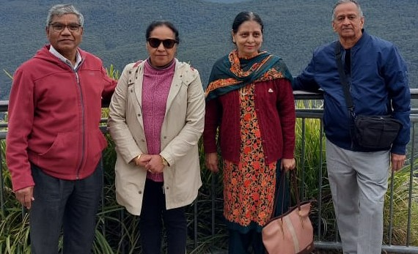  With Mr. C.K. Verma & Mrs. Verma at Blue-mountains, Sydney, Australia.

Full Name | Chandra Prakash Soni
Nick Name | B.E.
Branch | Mechanical
Email | chandrasoni5156@gmail.com
Phone | 9826295806
Current Location | Dewas, M.P. (India)
Educational Qualification | Bachelor of Engineering
Professional | I am currently working as a consultant in two small units in Dewas.  Work as a GET in Gajara Gears Ltd Dewas  Work as a manager in Steel tube Ltd Dewas  Work as a senior general manager in uttam gelva Steels Ltd khapoli maharashtra
Family | Wife - Kiran Soni  Daughter - Shikha Soni (married)  Son - Vikas Soni (Expired on 07/08/2026)
Memory from College Days | ---

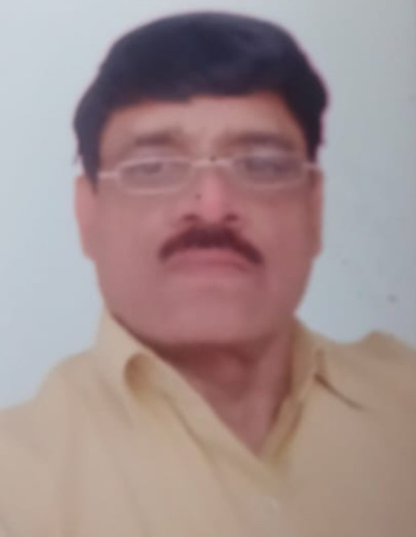
Chandra Prakash Soni: Now

Full Name | Jaikumar Shankerrao Kakpure
Nick Name | Jaikumar
Branch | BE(Electrical)
Email | jaikak3385@gmail.com
Phone | 7788815063
Current Location | 3385 Church Street Vancouver BC Canada
Educational Qualification | - BE(Electrical) 1971-1976  - Won Gandhi Memorial Scholarship for Rs 1,000 per year for 5 years.  - 22nd Batch, BARC Training School (1978)  - LLQP 2002  - CAIB-4 Level 3 2012
Professional | Joined February 1978 Government Engineering College for ME(High Voltage) dropped out to join BARC Mumbai 27-08-1979 as Trainee Scientists. Left BARC on 31-05-1983 to join Maruti Udyog Ltd Gurgoan on 03-06-1983 till 31-12-1989. Worked Deputy Manager(MSD) at manufacturing plant.  Joined Ispat Denro Ltd Kalmeshwar as Assistant General Manager(ISD) from 02-01-1990 to 30-06-1993.  Joined Steel Tubes of India Devas as Deputy General Manager 02-07-1994 till 30-04-1995  Joined Rajinder Pipes Ltd Mumbai as Group Head IT 01-05-1995 till 30-05-1997  Joined Mather & Platt Pune from 01-06-1997 as Senior General Manager(IT) at Chnivhwad plant upto  30-05-2000.  Joined IBM Global Service for Ballarpur Paper Ltd  Site In charge for group IT head from 01-07-2000 till  31-08-2001.  Moved to Vancouver BC Canada on 20-09-2001 as Permanent resident. Work a call center RMH as Supervisor for 3 year 6 months.  Senior Sales consultant with The Brick for 10 years.  After age 60 Self-employed as Independent Insurance Broker for Life and General Insurance as Designated Nominee Director.  Owner and Director of Abha Financial Services Ltd from 02-10-2026 till date.
Family | 13-05-1984 wedded Dr. Veena Jai Kakpure at Bhilai Tamil Bhavan. One son Ravi born on 04-05-1985 at Gurgaon.  Wife did MD(Microbiology) 1990-1993 from Government Medical College.  She is still working as Manager(QA) from 02-07-2003 till today for Enviro Health Research Labs Ltd.  Son works for Canada Post as letter carrier and got wedded last year with Russian girl Helen.
Memory from College Days | In year 1971 I came to see late Chandrashaker Tiwari to see him in hostel C and college building. I was highly impressed. Few months later, accompanied by father came for admission in the month of July 1971. Joining NCC and Civil Defense activities are still fresh in memory.

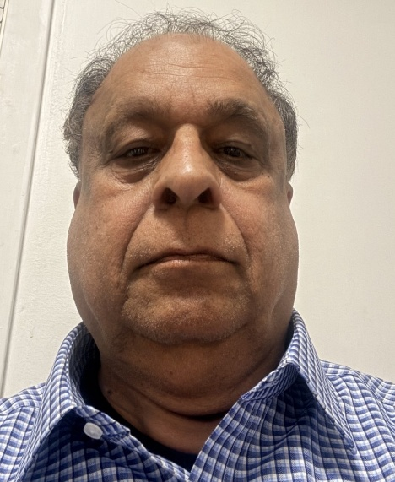  Jaikumar Shankerrao Kakpure: Now | 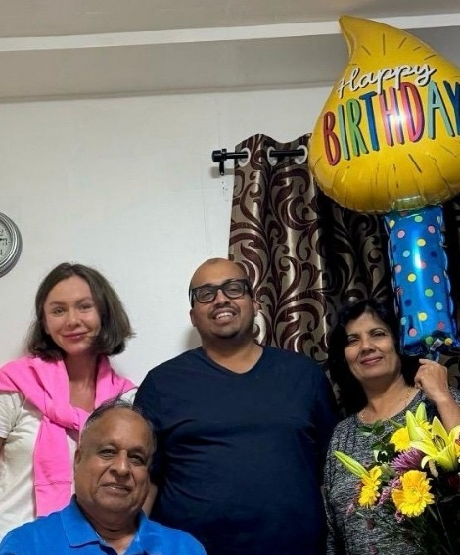  Birthday party at home
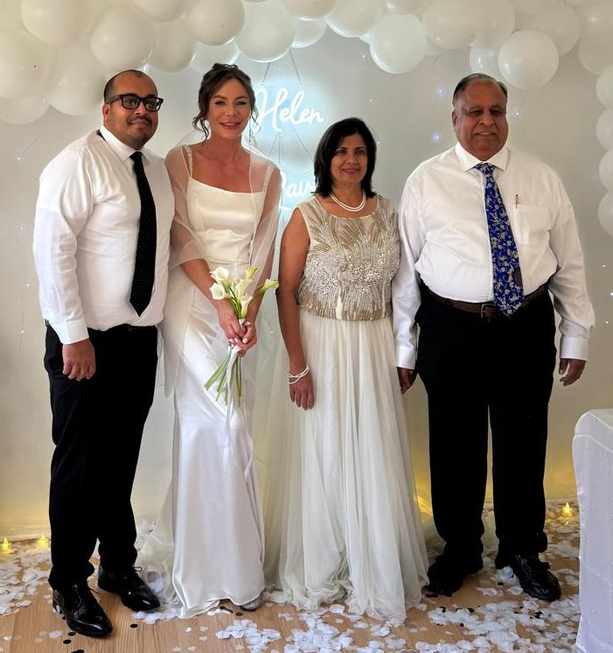  Our Family Photo Myself Spouse Son and Daughter In Law Wedding | 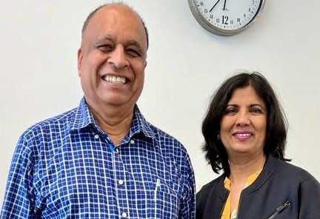  At home with spouse

Full Name | Rajesh Kumar Shrivastava
Nick Name | Rkshrivastava
Branch | Civil
Email | r.k.shri26@gmail.com
Phone | ---
Current Location | Pune india
Educational Qualification | B. E. Civil
Professional | Worked in water resources depth. Mostly in hasdeo bango project. Korba.
Family | Wife Namita Shrivastava, M.Sc. She is from Senoi M.P. I have two daughters, both are software engineers and are working in M.N.C. Pune
Memory from College Days | ---

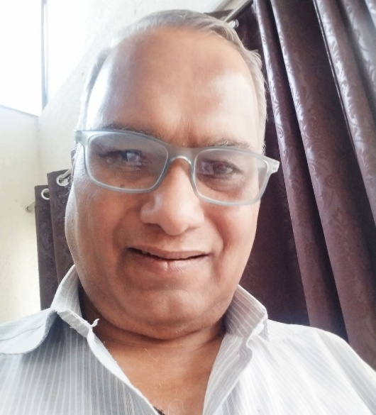  Rajesh Kumar Shrivastava: Now | 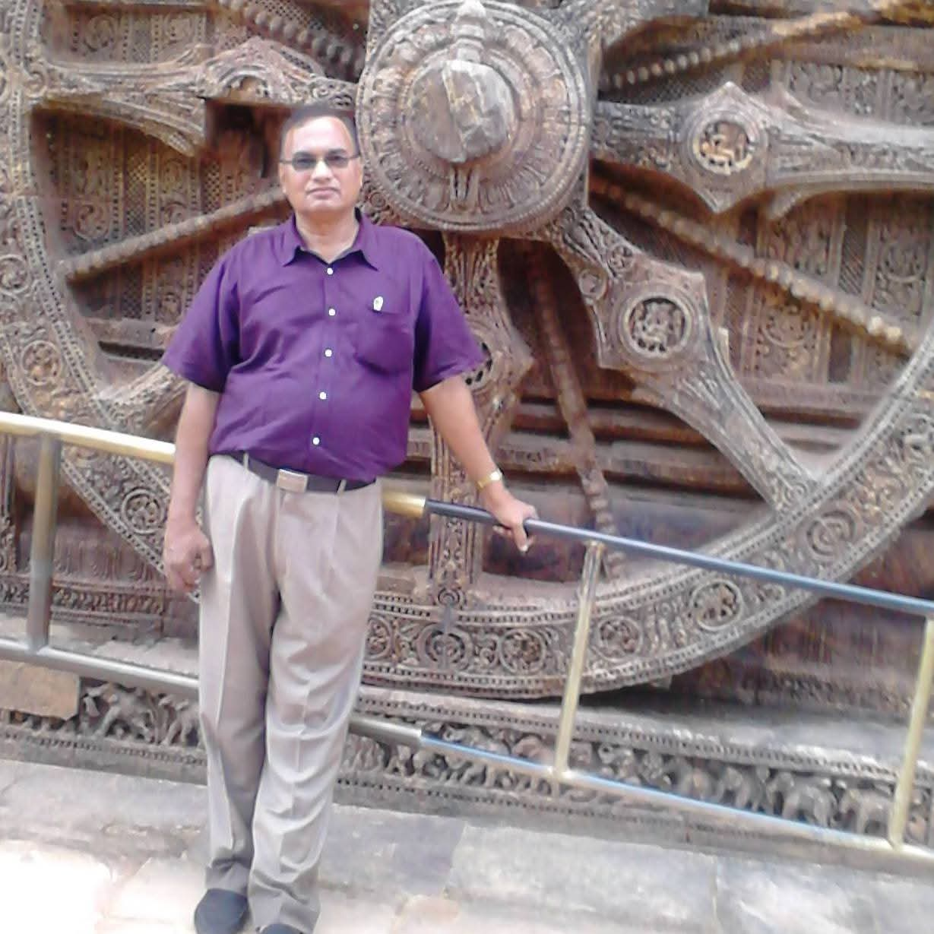
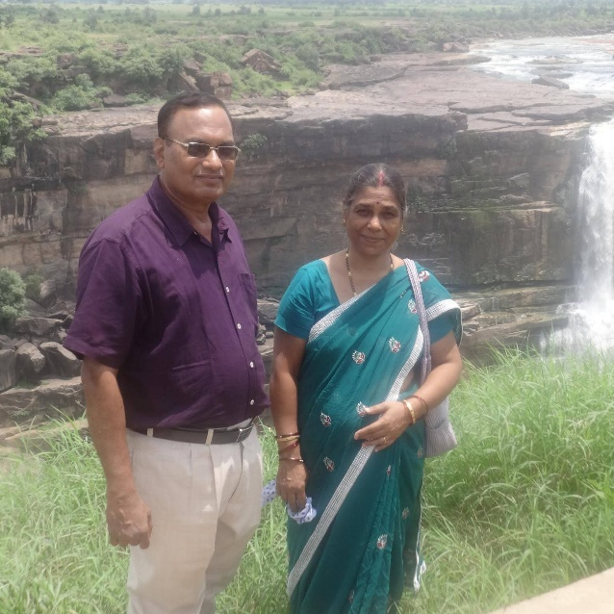  Rajesh Kumar Shrivastava with Spouse | 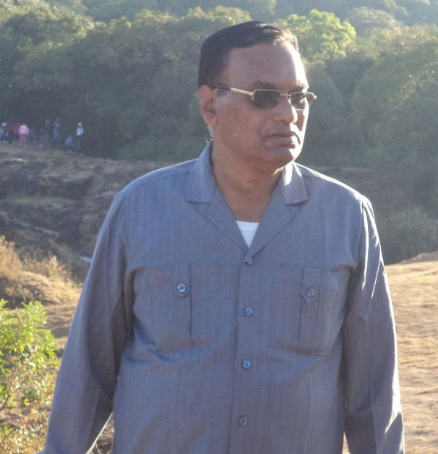

Full Name | Pawan Jain
Nick Name | --
Branch | Mining
Email | icejhsttwo@gmail.com
Phone | 9415057564
Current Location | Jhansi (U.P.)
Educational Qualification | B.E. (Mining)
Professional | Joined the parental business of Mining in 1976 , successfully set up & commissioned a comprehensive mineral processing plant in 1976, mining operation were gradually converted into mechanized mining operation .In 1982 established a state of the art refrigerated warehouse (Cold Storage) facility in Jhansi .Founder of Eastern Refractories Pvt Ltd manufacturing high performance Refractory Bricks & Castable . Following structural family partition concentrated on cold chain business. Mining & Mineral processing is taken care of by family
Family | At the heart of our home is Priti a dedicated home maker whose warmth and unwavering support have been the quiet force behind all our collective achievements. I am blessed with 1 son & 2 daughters who have each charted remarkable professional path. Son looks after our family business .My both daughters have carved out successful lives & careers for themselves in the USA their achievements remain a profound source of pride for the entire family.
Memory from College Days | A student protest demanding the postponement of exams , a bus was set on fire by some students , resulting into my Journey to Raipur Jail in 1972 for 6 days .It was a sobering experience a story of activism & sacrifice .

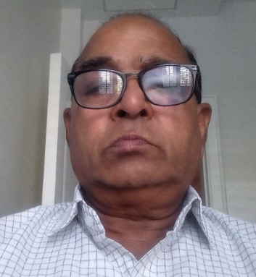  Pawan Jain: Now | 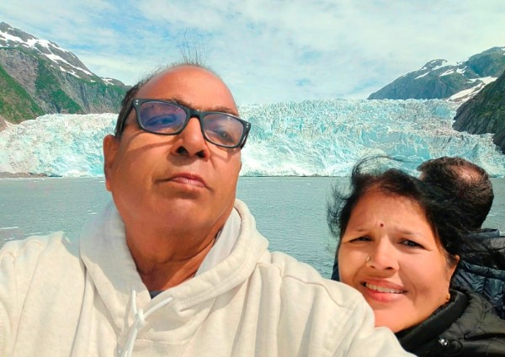  Pawan Jain with Spouse
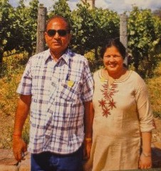 | 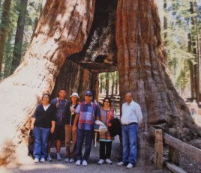  Pawan Jain with Family

Full Name | Chandra Kant Verma
Nick Name | C K
Branch | Mechanical
Email | ckv1310@gmail.com
Phone | 61422558130
Current Location | Sydney, Australia
Educational Qualification | • BE Mechanical, GEC (NIT) Raipur 1976  • ME (Turbomachines), IISc Bangalore 1978
Professional | • Manager at BHEL Hyderabad, Ramachandrapuram 1978 – 1991  - Research and Development Engineer Pumps 1978 – 1986  - Worked in the upgrade of Pumps used in power plants.  - Indigenization of Pumps components used in Nuclear and Thermal power plants.  - Developed High energy pumps used in Refineries.  • Migrated to Australia in 1991  • Chief Engineer at Weir Engineering 1991-2010  - Design and development of various pumps used for Australian Frigate Ships.  - Design and development verities of Pumps based on applications.  • Chief Engineer at Hydro Australia 2010-2018  - Pump upgrades of High integrity pumps to bring them to current design practice .  • Chief Engineer Pumps at Sulzer Australia 2018 – 2023  - Supporting the company and Pump Industries to sort out various issues and upgrades.  • Chief Engineer Pumps at Industrial Plant Services Australia 2023 –Till Present  - Supporting the team on various upgrades in the field of Rotating equipment .  - Mentoring Young engineers and imparting the Knowledge and Experiences .  - Components development using various current Technology.
Family | • Married to Rajeshwari Verma in 1985. She is Post Graduate from Degree girls College Raipur. Worked in a government lab in Sydney. Recently retired. We follow both local and Indian culture and well connected to both Australian and Indian communities.  • Daughter (Garima Verma) is Graduate in Economics and Law with major in Economics. She works as a consultant in the economics. Developed self interest in Indian culture and dance as hobby. Proficient in “Bharatnatyam Dance “. Currently learning “Katthak “along with her daughter Esha (8 years)  • Son (Gunjan Verma) Dentist specialized in “Special Care Needs He has his own practice since 2023. Well settled in Sydney
Memory from College Days | • Mani Ram Canteen.  One Sunday morning few of us went to canteen for tea. The waiter’s nick name was “Chavanni “. We were waiting for the Tea for a while. Then started raising our voices to Chanvanni to hurry up. By listening our high pitch voice, Mani Ram (the owner) picked up Chavanni’s ear and brought him in front of us. Then, He shouted to Chavanni in High Pitch “Aree, Sahab log Kutte Ke Mafic Bhonk Rahe Hai Aur tu Kan Nahin Dharata”  We enjoyed the Tea. But realized the sarcastic statement bit later.

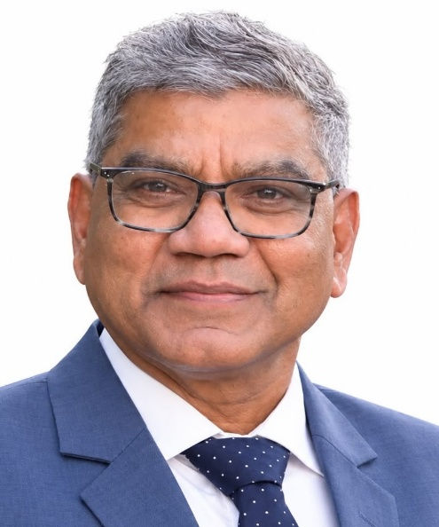  Chandra Kant Verma: Now | 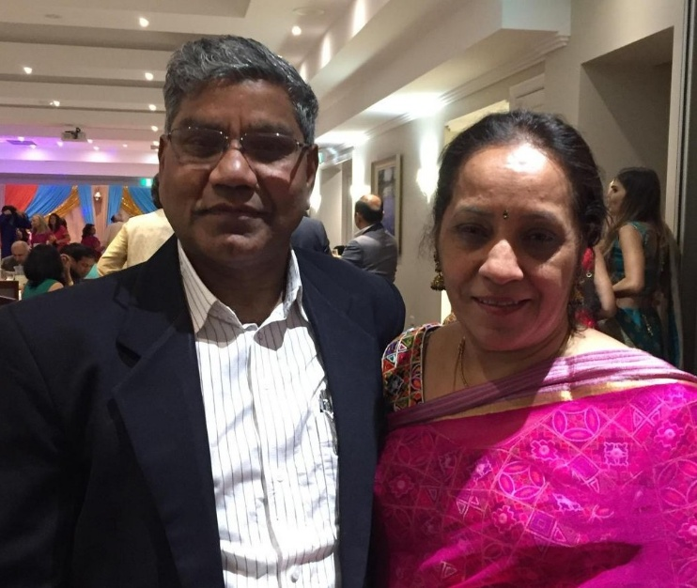  CK Verma with spouse Rajehwari Verma In traditional Indian Saree

Full Name | Santosh Kumar Sainik
Nick Name | --
Branch | Civil
Email | lavanya11389@gmail.com
Phone | 7587166431
Current Location | Bhilai, India
Educational Qualification | BE (Civil Engineering)
Professional | I have retired as AGM, from Civil Design (BEDB), Bhilai Steel Plant. During my entire career, I have cherished a lot of interesting & challenging design work and met knowledgeable people who have helped me to evolve both in my career and personal life. It has been an incredible ride since college!
Family | My late wife and I are blessed with three daughters, and our family has blossomed to include four grandchildren. By God's grace, our children are all thriving both personally and in their chosen careers. Our eldest daughter is a Doctor (MD. Pathology), her husband is also a Doctor (MD. Biochemistry & DCP). Our second daughter is also a Doctor (MD. OBS & GYN), married to an MD in Anesthesia. Our youngest, is a Senior Engineer (Alumni from IIT Kharagpur - married to a Master’s in Management Professional, Dublin (Ireland), and settled in Europe now.
Memory from College Days | --

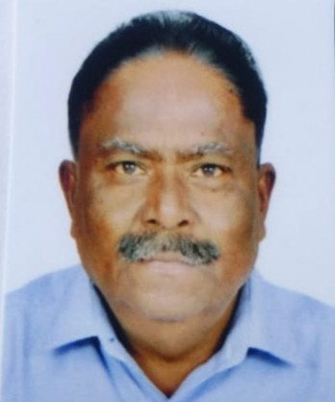
Santosh Kumar Sainik: Now

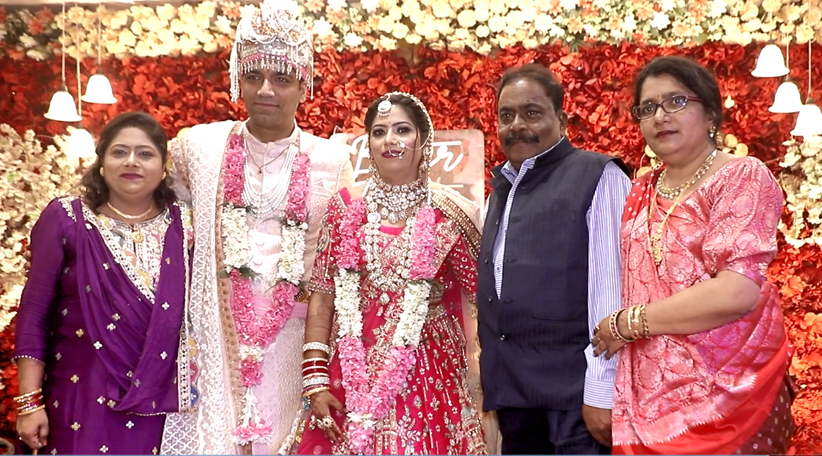
Family photo during my youngest daughter's wedding

Full Name | Ramesh Punjabi
Nick Name | --
Branch | Civil
Email | rkpfo1itd@gmail.com
Phone | 9407910795
Current Location | Raipur, India
Educational Qualification | BE (Civil)
Professional | Served as JE in MSEB at Aurangabad, Maharashtra.  Then served in Water Resources Department, MP/CG from 22.4.1982 to 31.01.2017.  Retired as Chief Engineer.
Family | Wife Smt. Sunita Arora, Housewife.  Son Akash Arora, operating a shop.  Daughter Palka Arora, Settled in Melbourne, Australia.
Memory from College Days | My principle was: Apne aap ko jyada tension dene ka nahi.  Jo easily samajh aaye wahi padhne ka  Wo bhi bas passing marks ke layak  😊

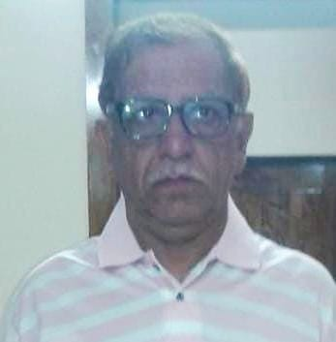  Ramesh Punjabi: Now | 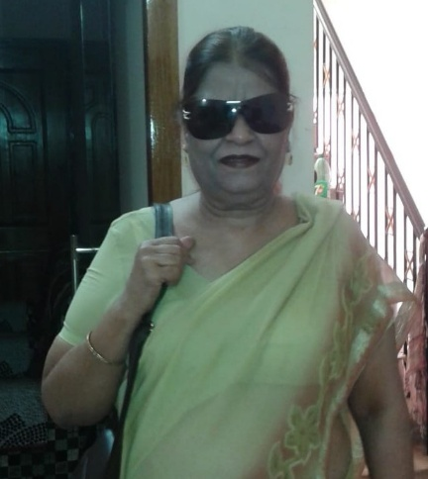  My Better Half
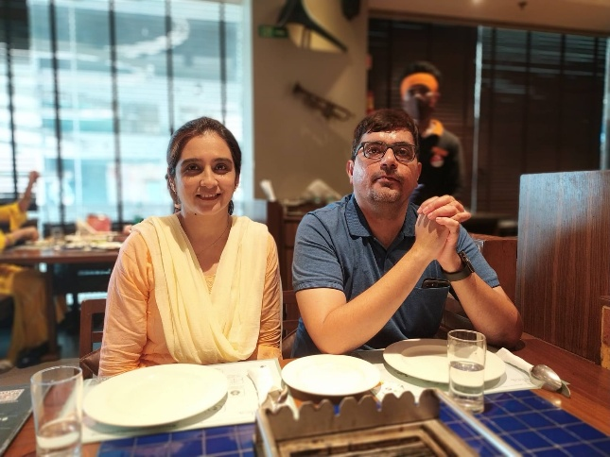  Son and Daughter-in-law:  Aakash and Priyanka Arora | 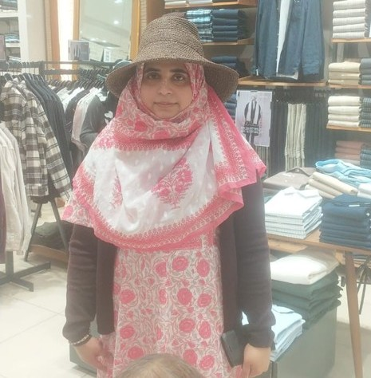  Daughter : Palka Arora

Full Name | Madhusudan Lal Amrit
Nick Name
Branch | Mechanical
Email | amrit20priya@gmail.com
Phone | 7587441554
Current Location | Bhilai, Chhattisgarh
Educational Qualification | BE, Mechanical
Professional | I started with NMDC in 1978 and later workrd at the Bhilai Steel Plant for 35 years and retired as a DGM in 2015.
Family | I have 3 daughters and a son. Two of my daughters are software engineer, married and settled abroad in USA and Japan. My youngest daughter is a dentist and my son runs his business after his post-graduation in commerce. My wife and I live in Bhilai and spend half of our time at our native place near Bhilai.
Memory from College Days | I still remember Joshi Sir and his vector algebra classes. Those were great days. His class would often commerce at 4 or 4:30 pm. And even after GG we all used to attend his classes very fondly. And our Chemistry Professor, also Joshi Sir, who would often joke in the classes and had his favorite student in the class Mohan Golcha.

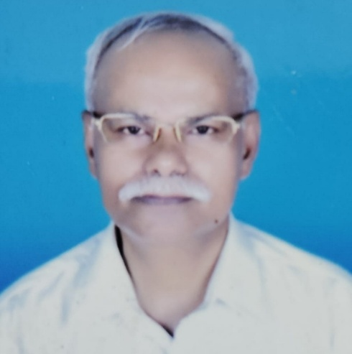  Madhusudan Lal Amrit: Now | 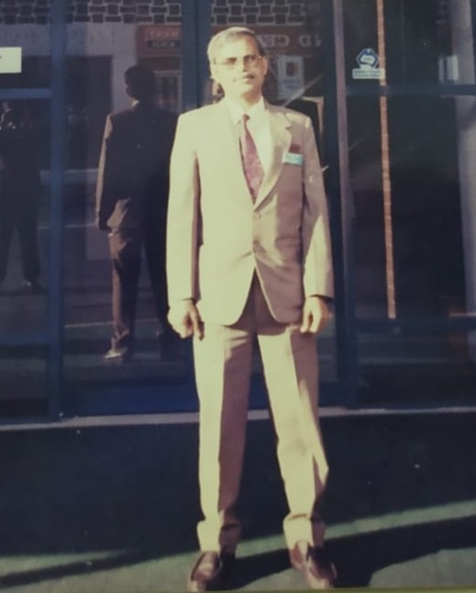  This photograph is from my first visit abroad and reminds me of older times

Full Name | B L Agrawal
Nick Name | Bajrang
Branch | Electrical
Email | blagrawal@hiragroup.com
Phone | 9893038002
Current Location | Raipur, Chhattisgarh, India
Educational Qualification | Done 10th and ISC from Kharsia and BE Electrical from NIT Raipur
Professional | After passing out engineering in 1976, I started looking after the family run tyre trading business in 1980. For a short stint in the year 1982 I Started working in a Dam Project in MP. I ventured into manufacturing and started Jai Bajrang Cement in 1986. In parallel, we started a Ferro Alloys Plant in 1988 in Urla Industrial Estate, Chhattisgarh. And in 1977, the foundation for first 350 tpd sponge iron plant with 10MW Power plant was laid and there the Journey of our parent company Godawari Power and Ispat Limited started. Today we are a steel conglomerate of Central India with mining, pellet, sponge, billet, wire rod, renewable energy, real estate businesses under our wings. The Group stands at a consolidated top line of over 6000 crore with a market cap of about 15000 crore.
Family | I am a strong believer of Sanyukt Parivar. Even today, after so many decades, our joint family is intact. At least once a year, the entire family — children, elders, everyone — sits together.” Family governance in the HIRA Group was never a formal boardroom framework. It was something far older, deeper, and rooted in tradition. It was built on shared meals, shared festivals, and shared responsibilities. I created our first unit—built entirely on instinct, courage, and the quiet assurance that my family stood behind him. Today the second and third generation have taken up the responsibility of taking the group to new heights and I observe, intervene if there is any major concern and act as advisor. For new business we still sit together as family, discuss all pros and cons and then decide whether to take it forward or not. Being it a new business, expansion, capex, we all brainstorm and get to a conclusion.
Memory from College Days | Engineering friendships have their own current—once the circuit connects, it never breaks. Sharp minds, sharing the same branch, sharing the same benches, and often the same trouble. We were like conspirators in curiosity. The group of 3-4 friends, the friendship which started as laughter over chai at the campus gumti became a camaraderie that travelled through fifty years of life

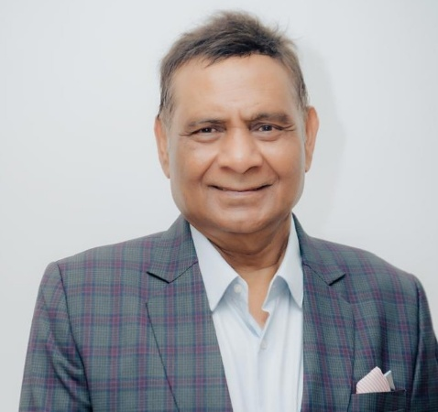  B L Agrawal: Now | 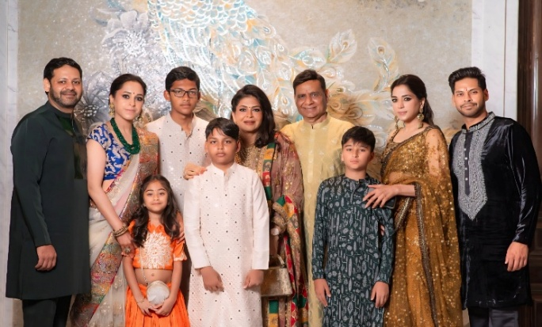  Ek sanyukt pariwar, har choti badi chunotiyon to chota bana deti hai
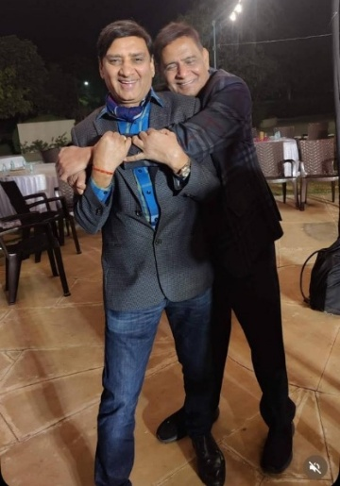  One can be stupid with friends, with no judgements made | 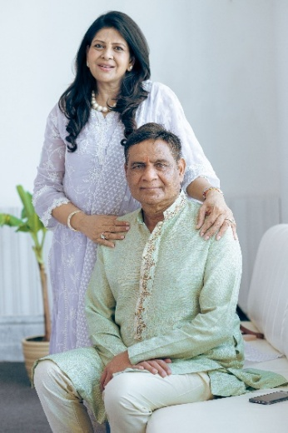  A constant anchor through Life's ups and downs, keeping family together

Full Name | Vinod Kumar Jain
Nick Name | Vinod
Branch | Electrical
Email | vkjaintbg@gmai.com
Phone | 9575855644
Current Location | Bhopal, M.P.
Educational Qualification | B.E Electrical, MIICERA
Professional | Act apprentice - Century Cement Tilda, Joined BHEL Hardwar 1977, Worked for Power project Division- Thermal and Industrial Steam Generating plant up to 200 MW, Head of Department- works engineering service, quality , engineering and lab , Transferred to Transmission business Group - project manger , commissioning head, construction . Worked at headquarter, project sites, Indian and foreign projects. Internal Faculty. Consultant, guest faculty .
Family | My wife is home maker. She is a postgraduate.  My son Ravi has done BE & MBA (Melbourne University). He is a NRI and is an Australian Citizen.  Daughter (elder) has BE in Chemical engineering and Computer Diploma. She is a Canadian citizen and presently in Pune India.  Younger daughter Sharmishtha Jain is presently a Commerce Faculty at Delhi Public School.
Memory from College Days | My first extempore speech and obtaining first prize created an opportunity to represent college for next 5 years. In the final year, I participated in drama with Sunil Mishra. Received help from Prafull Jaltare in engineering drawing. Received a blow for breaking a strike. Conducted student night function in final year. Was punished by Zadgaonkar sir in final year.

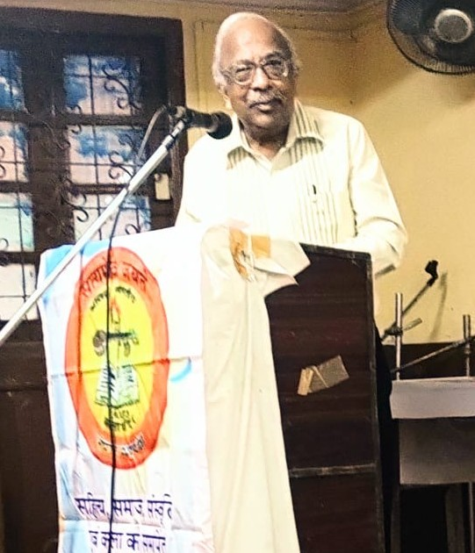  Vinod Kumar Jain: Now | 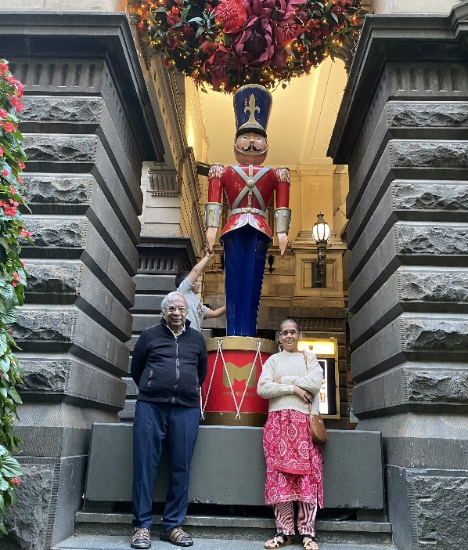  Vinod Jain with better half
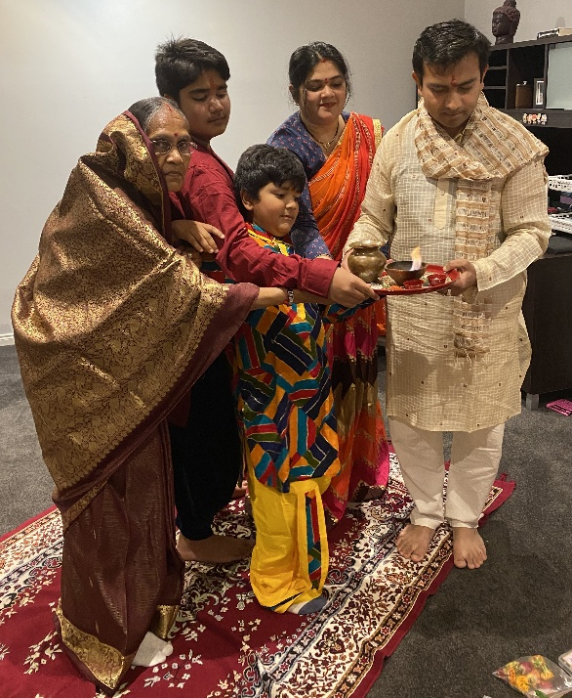
At Melbourne with son daughter-in-law and grandson

Full Name | Hiralal Tekchandani
Nick Name | Tekchandani
Branch | Civil
Email | hiralaltekchandani7@gmail.com
Phone | 9819526844
Current Location | Bangalore, Karnataka
Educational Qualification | BE, Civil
Professional | Irrigation, FCI
Family | Wife and three children
Memory from College Days | --

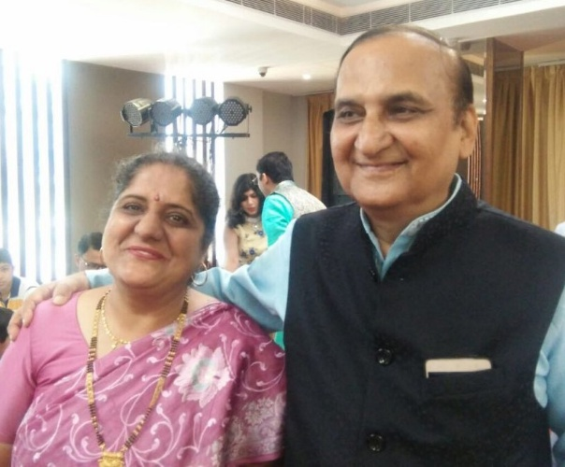
Hiralal Tekchandani: Now

Full Name | Bijan K. Dutta
Nick Name | Bijon
Branch | Mechanical
Email | bijon.dutta@gmail.com
Phone | 9757000363
Current Location | Kharghar, Navi Mumbai
Educational Qualification | B.E. (NIT Raipur), M.Tech. (IIT Kanpur), Ph.D. (IIT Bombay), Management Certificate Course (IIM Kozhikode)
Professional | Positions Served:  - Bhabha Atomic Research Centre: Different grades of Scientific Officer including Distinguished Scientist; Head, Human Research Development Division  - Homi Bhabha National Institute (A DAE unit): Vice Chancellor (Officiating); Dean; Senior Professor; Dean-Academic; Convener Board-of-Studies; Member Council of Management; Member Academic Council  - Fellowships: Dr. Raja Ramanna Fellow; Institute Chair Professor  - Visiting Scientist/Professor: MPa Stuttgart (Germany); Ohio State University (USA).  - Represented DAE: International Atomic Energy Agency (Vienna); Several international meetings on nuclear safety  Contributions as Engineering Practitioner/ Researcher/ Academician:  - Resolved a number of complex technical issues related to nuclear reactors, which enabled management to take crucial decisions with safety.  - Published 300+ research papers, including 130+ international journals.  - Guided thirteen PhD and fifteen M.Tech. students.  - Published a self-research-based book launched worldwide by Taylor & Francis (UK).  - Authored several book chapters including one published by WIT Press (UK).  - Served editorial boards of number of international journals.  National/International Recognitions:  - Internationally recognized as an expert in nuclear structural safety.  - Former president of the International Association for Structural Mechanics in Reactor Technology (USA). Presently advisor for lifetime.  - Chaired senior level meetings of DAE, IITs, and the Ministry of Defense.  - Life member of Indian Nuclear Society and Indian Association for Computational Mechanics.  Honors:  - Technical Excellence Award (DAE), 1992  - Homi Bhabha Award for Science and Technology (DAE), 1997  - Distinguished Faculty Award (HBNI), 2015  - Lifetime Achievement Award (NIT, Raipur), 2024  - Designation by AICTE as a Distinguished Professional, 2025  - A Fellow of the Indian National Academy of Engineering (INAE), Since 2004
Family | I married Gopa in 1985. She holds master's and B.Ed. degrees and worked as a lecturer in New Mumbai after our marriage. She later left teaching to focus on caring for our family as a homemaker. We have two children, Pramit and Prapti; both are engineers with master’s degrees. Pramit joined the DAE unit and worked for 10 years. He later moved to Europe to work in Maynooth. Presently, he is employed in a multinational company to work in ML and AI based applications. After completing B.Tech., Prapti moved to USA and earned her MS from NC State University. She joined Advanced Micro Devices (AMD) as an MTS Silicon Design Engineer and is now settled in California. Both are married.
Memory from College Days | Due to urgent work, my father did not accompany me the day of admission to our college. There were number of forms that were to be filled where parent/guardian signatures were required. I signed all the forms on behalf of my father. Everywhere it worked, except NCC. After seeing my form, Dave sir asked me, ‘Kiska signature Hai’. I said, ‘Father kaa’. Then he asked, ’Kisne kia’. I said ‘maine’. He said, ‘Abhi tak college mein admission bhi nahin liya aur badmashee chalu. Jao kisi guardian ka signature leke aao’. Thanks God, parent of another student agreed to sign my form, and I could get admission in our beloved college.

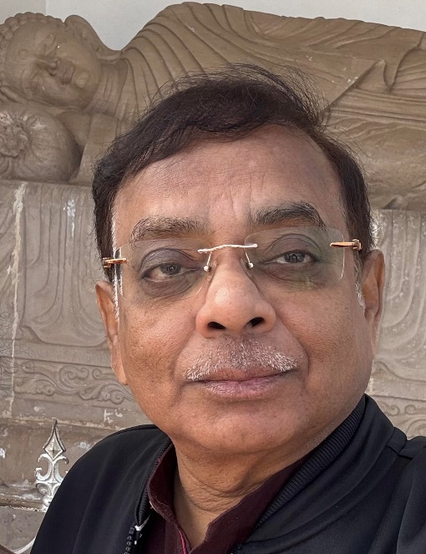  Bijan Dutta: Now | 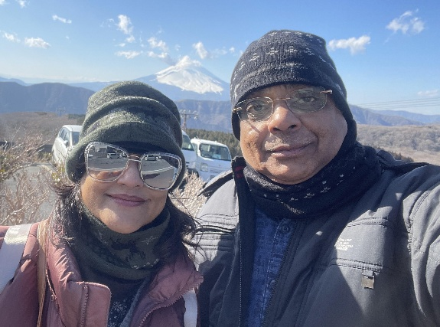  With better half Gopa and best half Fuji
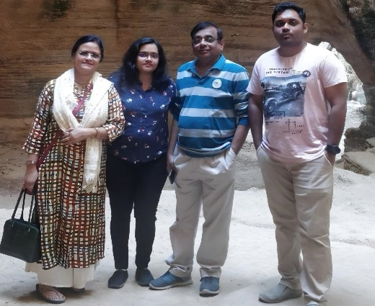  A family photo:  Gopa (spouse), Prapti (daughter), Me & Pramit (son) | 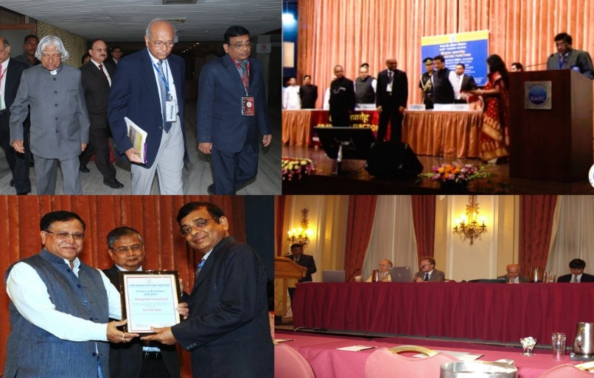  Top-Left: Accompanying Dr. Kalam & Dr. Banerjee on the way to attend a meeting in Ashoka Hotel, New Delhi  Top-Right: Anchoring a function. On stage: Dr. Pranab Mukherjee & Mr. Prithivi Raj Chavan (then CM Maharashtra)  Bottom-left: Receiving an award from Dr. V. K. Saraswat (then Member NITI Aayog)  Bottom-Right: Addressing a group of nuclear experts in Zurich

